School Payment

Portal
www.schoolpaymentportal.com

Parent Guide to Getting Started

Contents
Creating a new account 3
Logging in to your School Payment Portal Account 7
Adding Students/Patrons to your School Payment Portal Account 9
Adding Saved Payment Source(s) 12
Saved Payment Source – ACH (Checking or Savings Account) 14
Saved Payment Source – Credit Card 17
Make a Cafeteria Deposit 19
Setting Email Reminders/Auto-Replenish 25
Email Reminders 26
Auto Replenish 28
Modifying/Removing Reminders 31
Meal Pre-Order 32
Confirmed Orders 38
Order History 39
Patron Order History 40
Exit Pre-Order 41
Log Out 41

Creating a new account
To access the School Payment Portal website, enter the URL www.schoolpaymentportal.com into any internet browser.
Click Parent Login
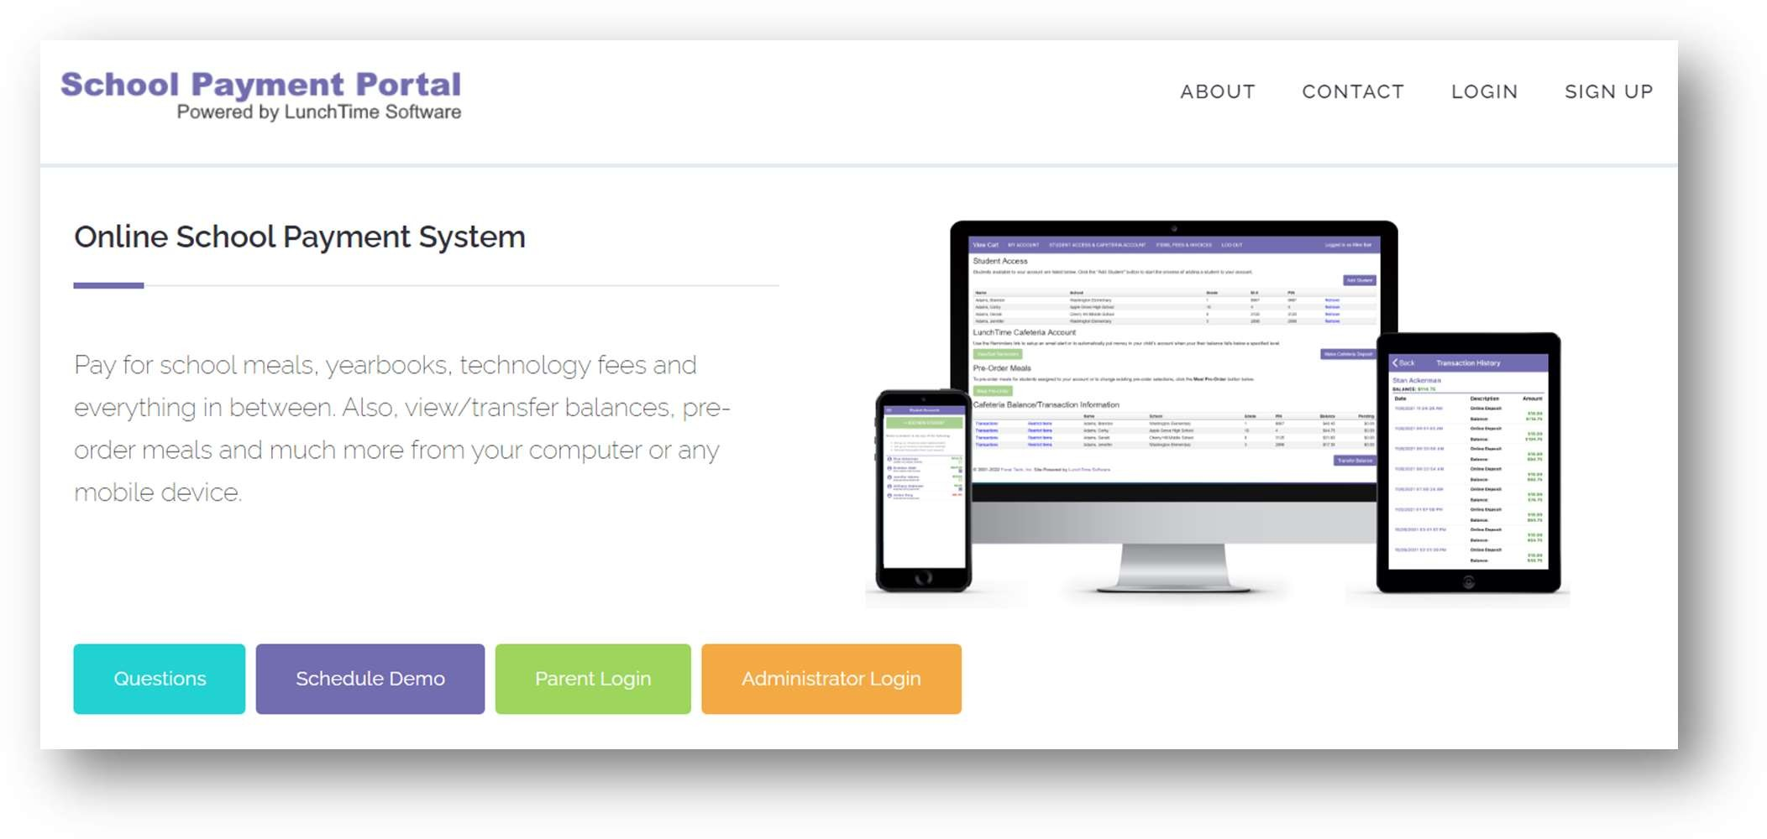

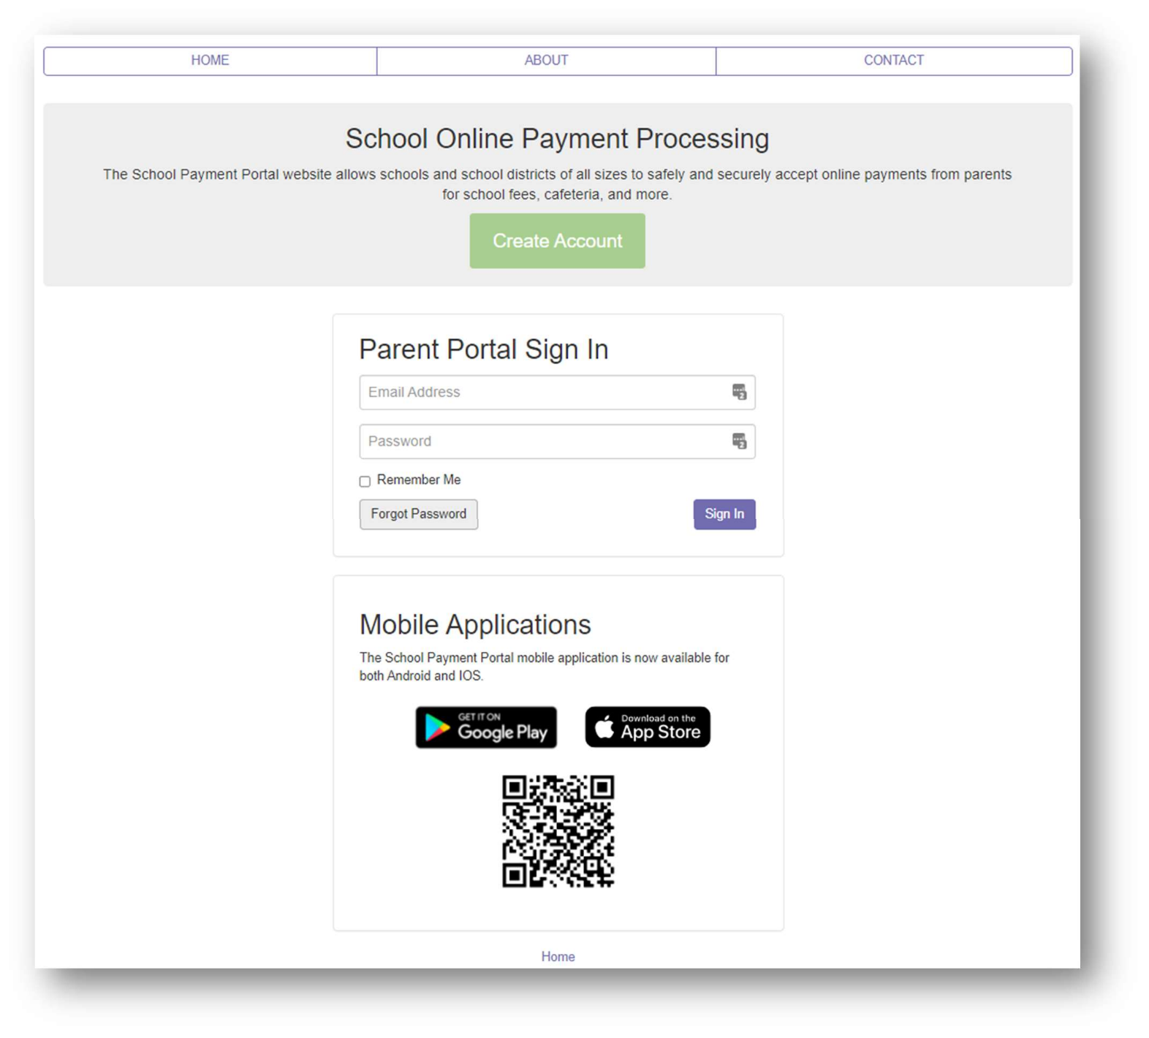
Click the Create Account button.

Fill in the required information, click the Create Account button when finished.
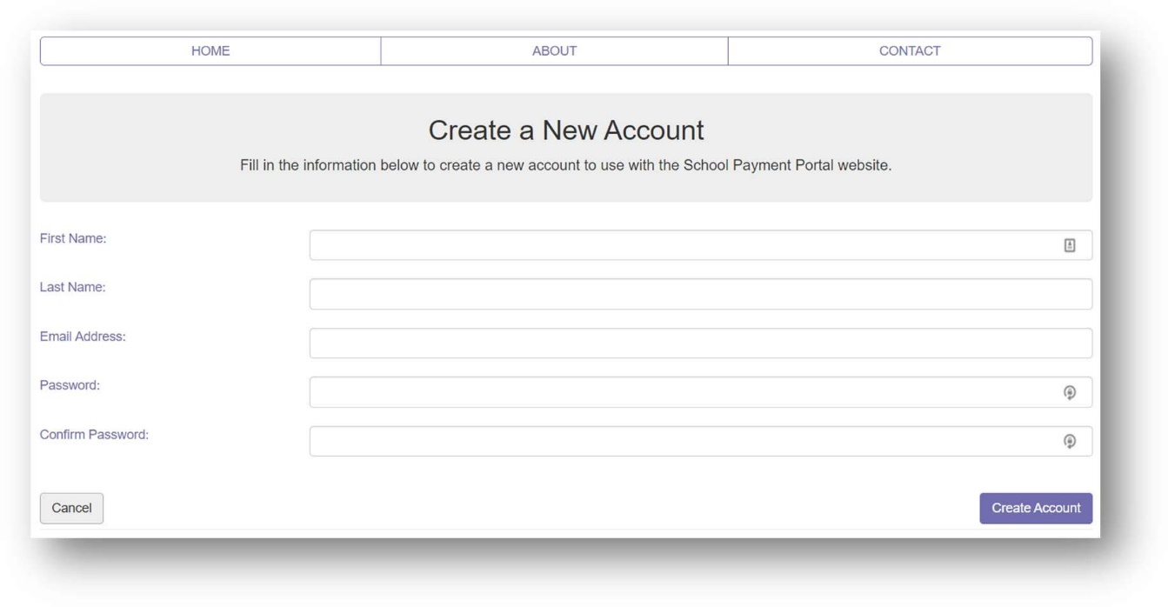

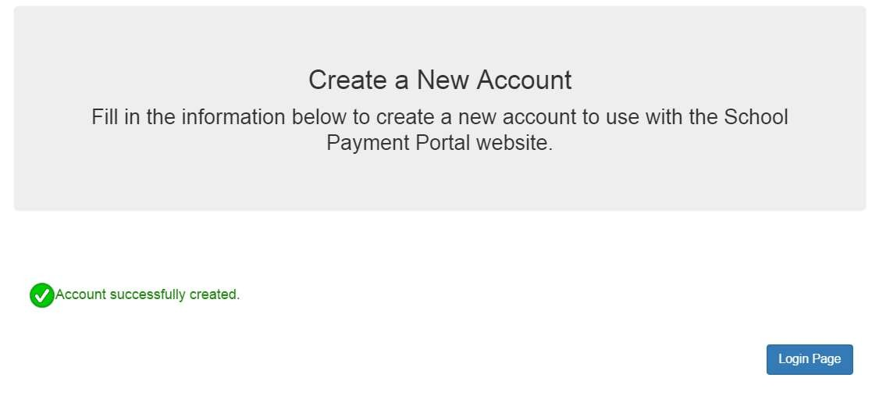
You’ll receive a confirmation that your account has been successfully created.

Logging in to your School Payment Portal Account
To access the School Payment Portal website, enter the URL www.schoolpaymentportal.com into any internet browser.
Click Parent Login
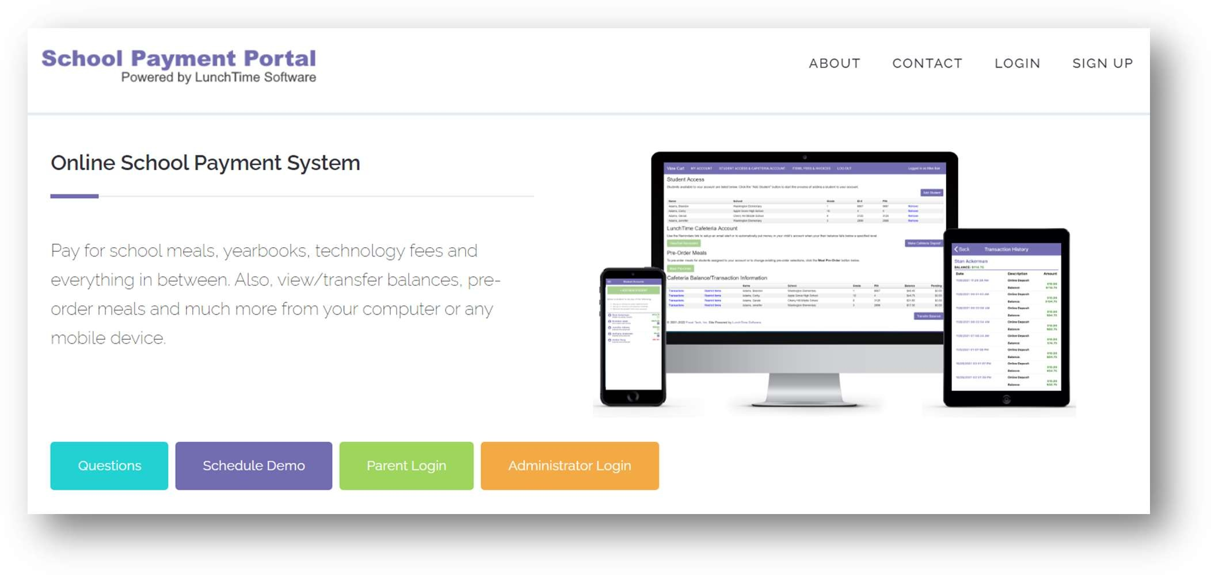

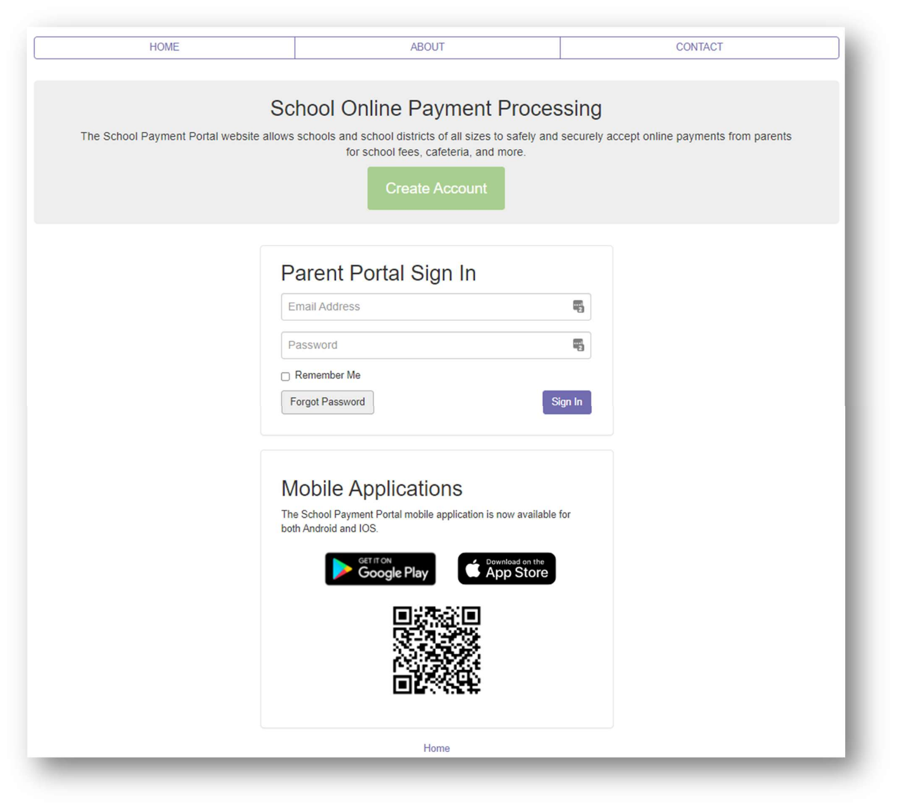
Fill in the Email Address and Password that were used to create the account. Click the Sign In button.

Adding Students/Patrons to your School Payment Portal Account
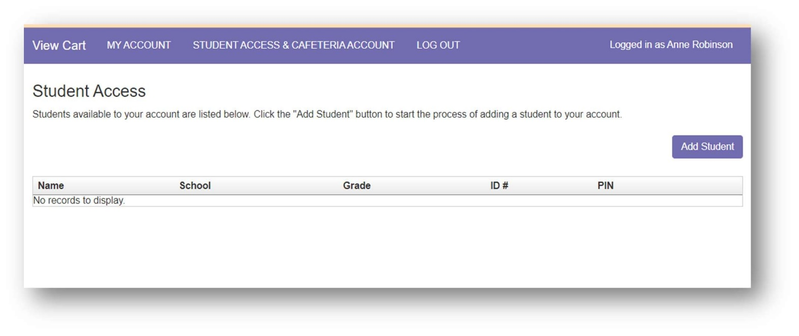
On the Student Access Page, Click the Add Student button.

Next, enter the zip code of the school, NOT your zip code, as they could be different for larger, multi-zip communities.
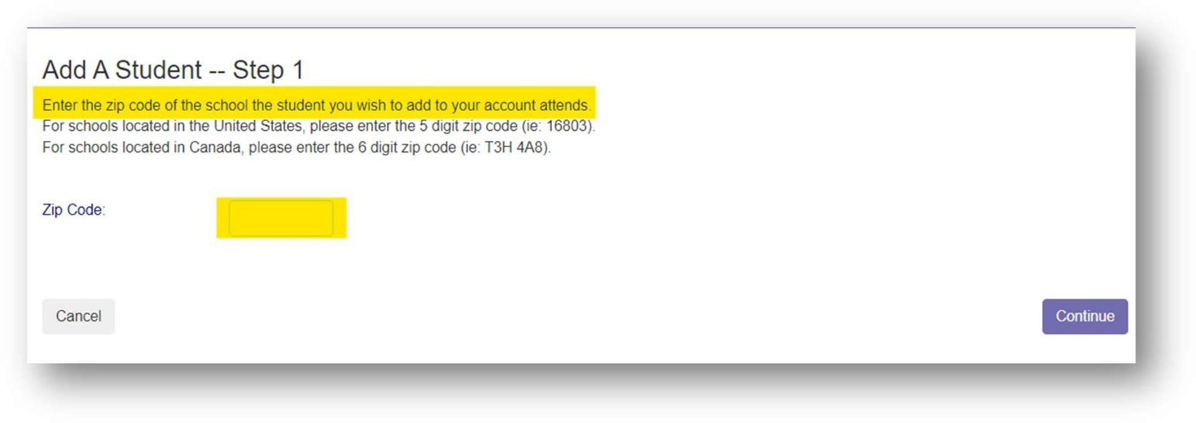

Next, select the school that the student/patron attends.
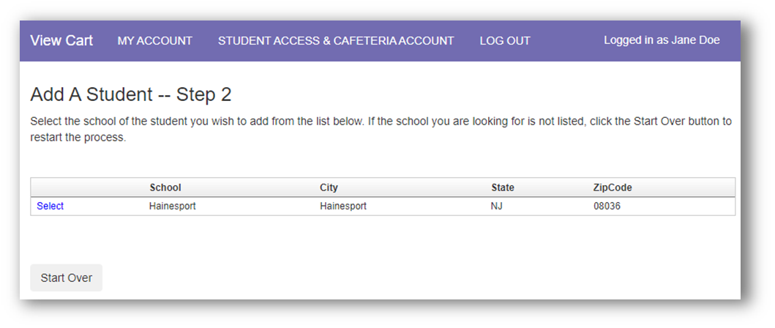

Enter the requested information for student/patron you wish to add to the account. The Student ID is the same
as the Local ID found OnCourse.
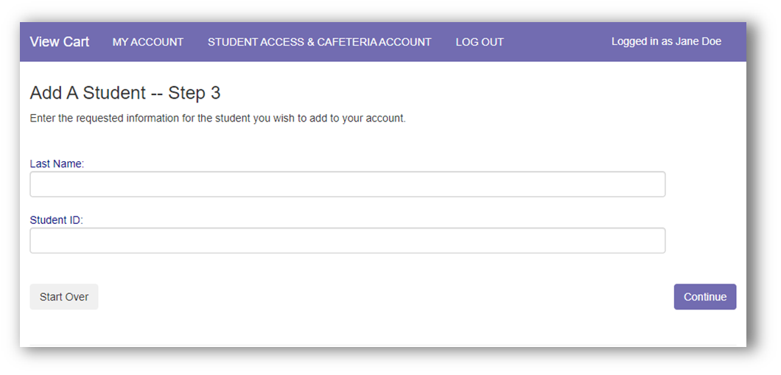
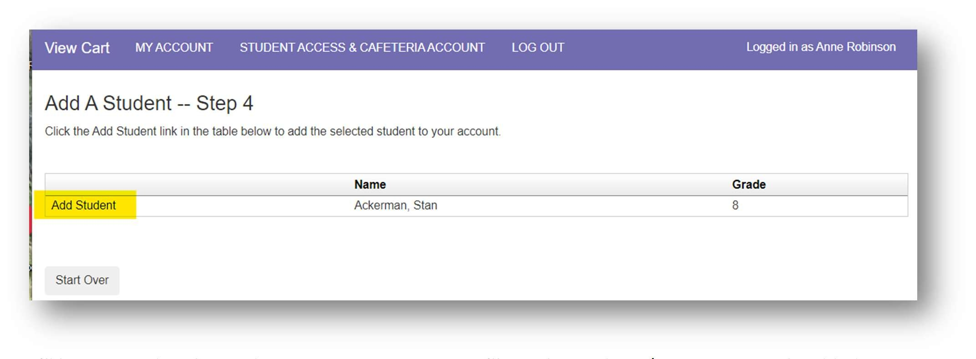
Click Add Student next to selected student/patron to add them to your account.

You’ll be returned to the Student Access page. Here you’ll see the students/patrons currently added to this account.
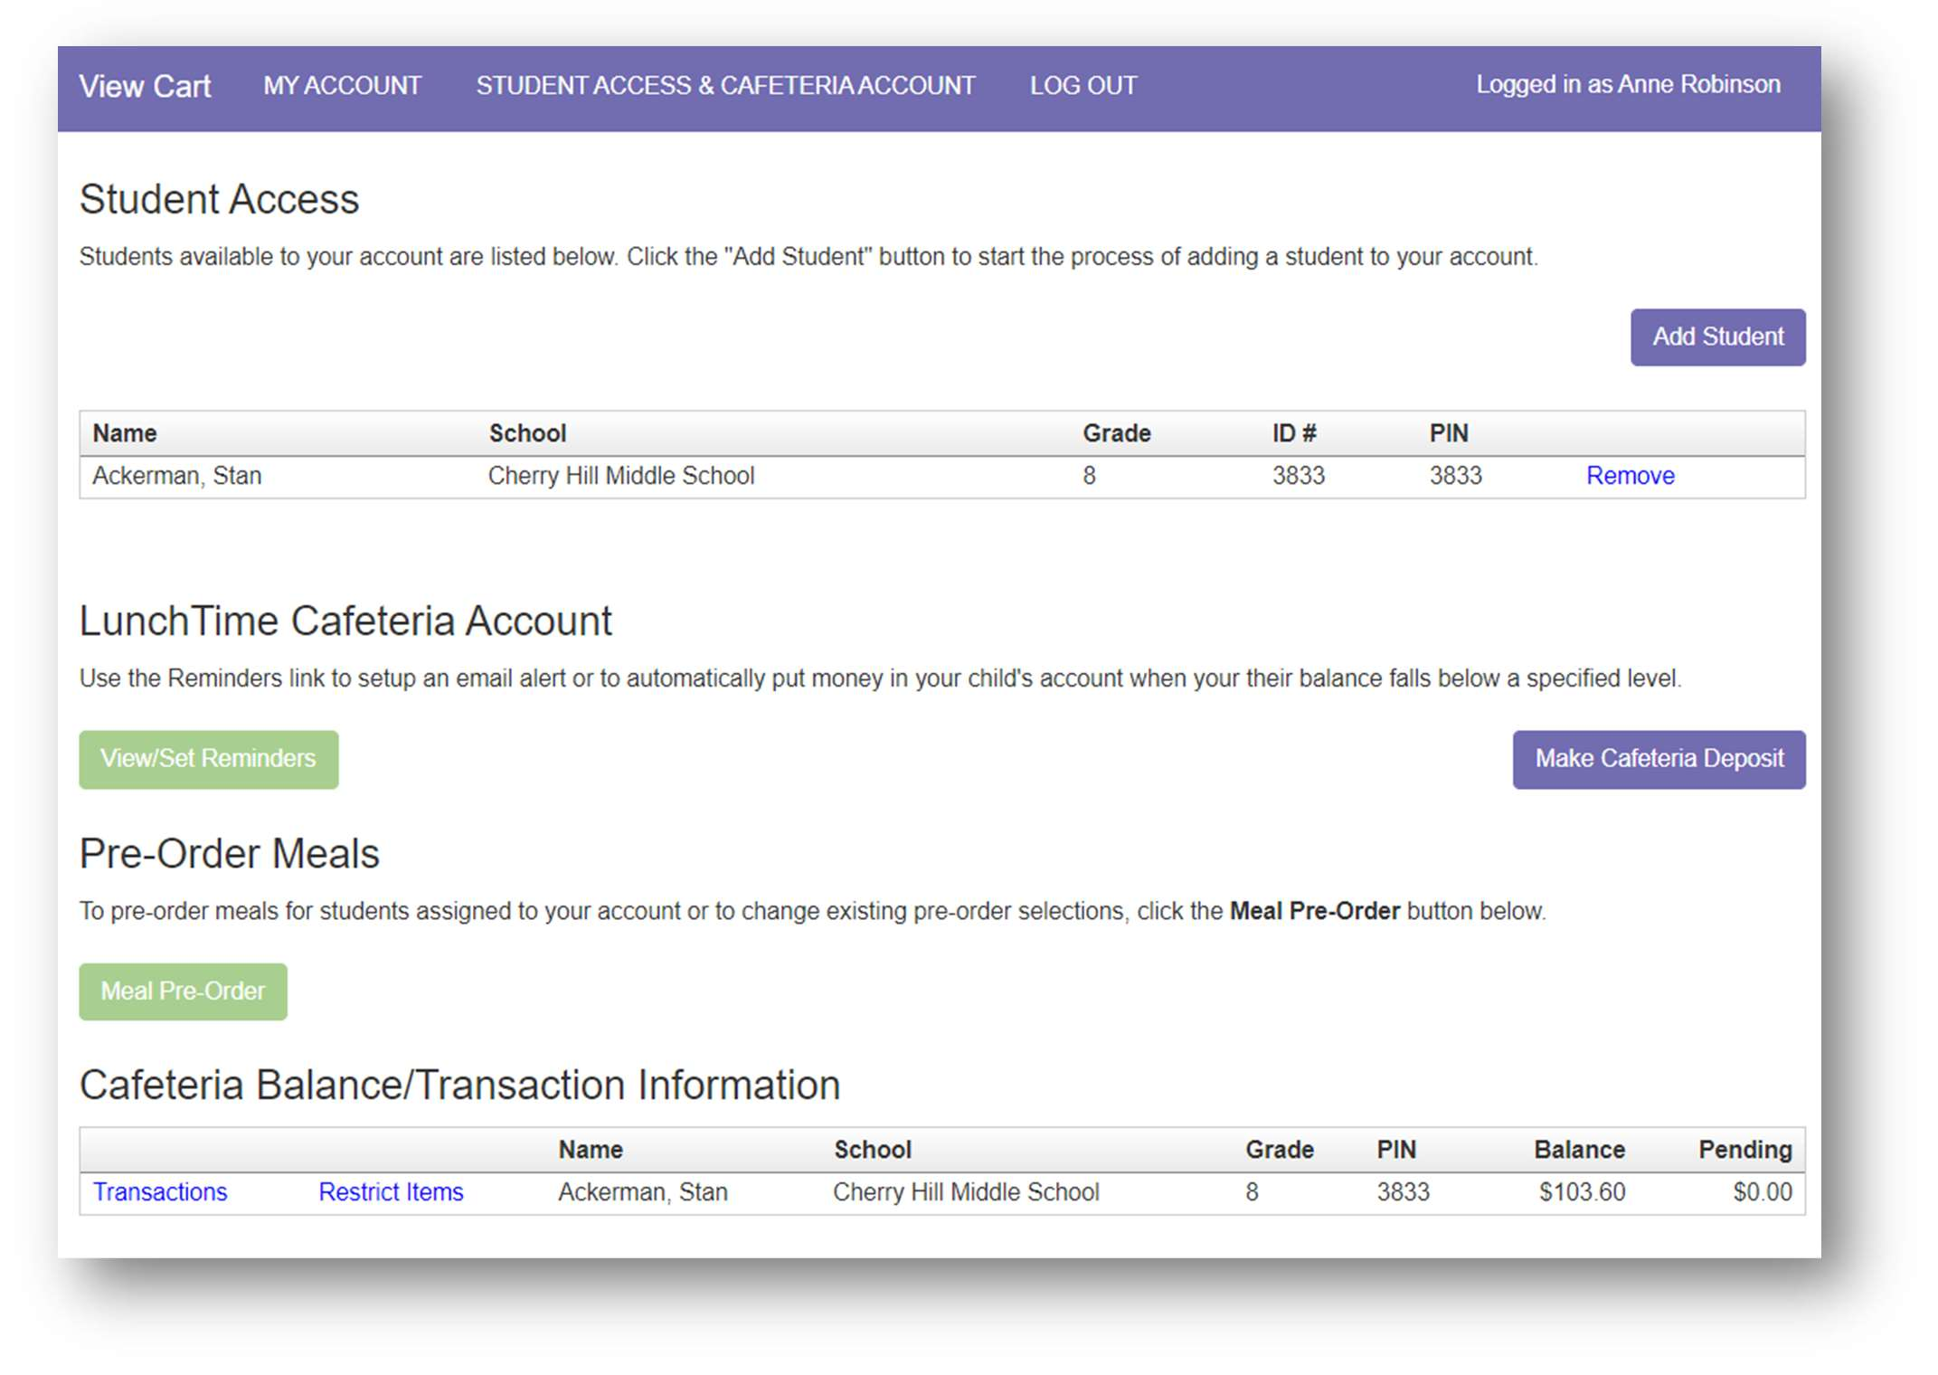
To continue adding more students/patrons to the account, repeat the steps on pages 9-11.

Adding Saved Payment Source(s)
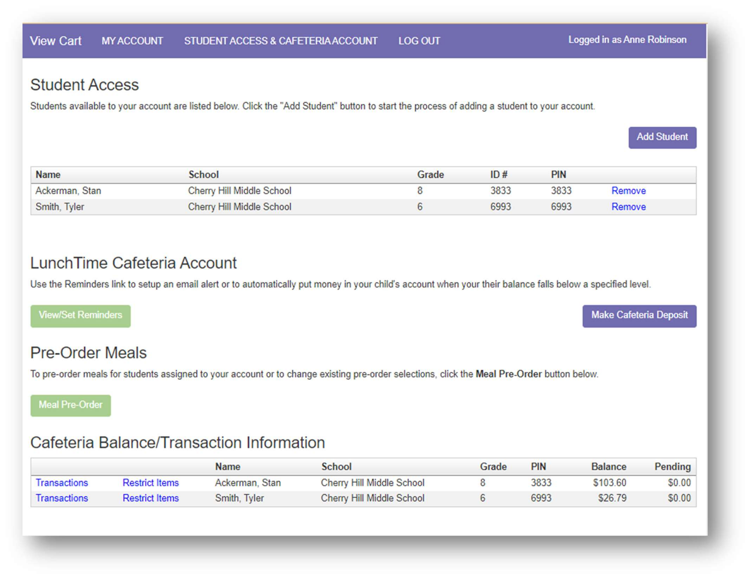
From the Student Access page, click MY ACCOUNT in the menu bar at the top of the page.

On the My Account Info page, click the New Saved Payment Source button.
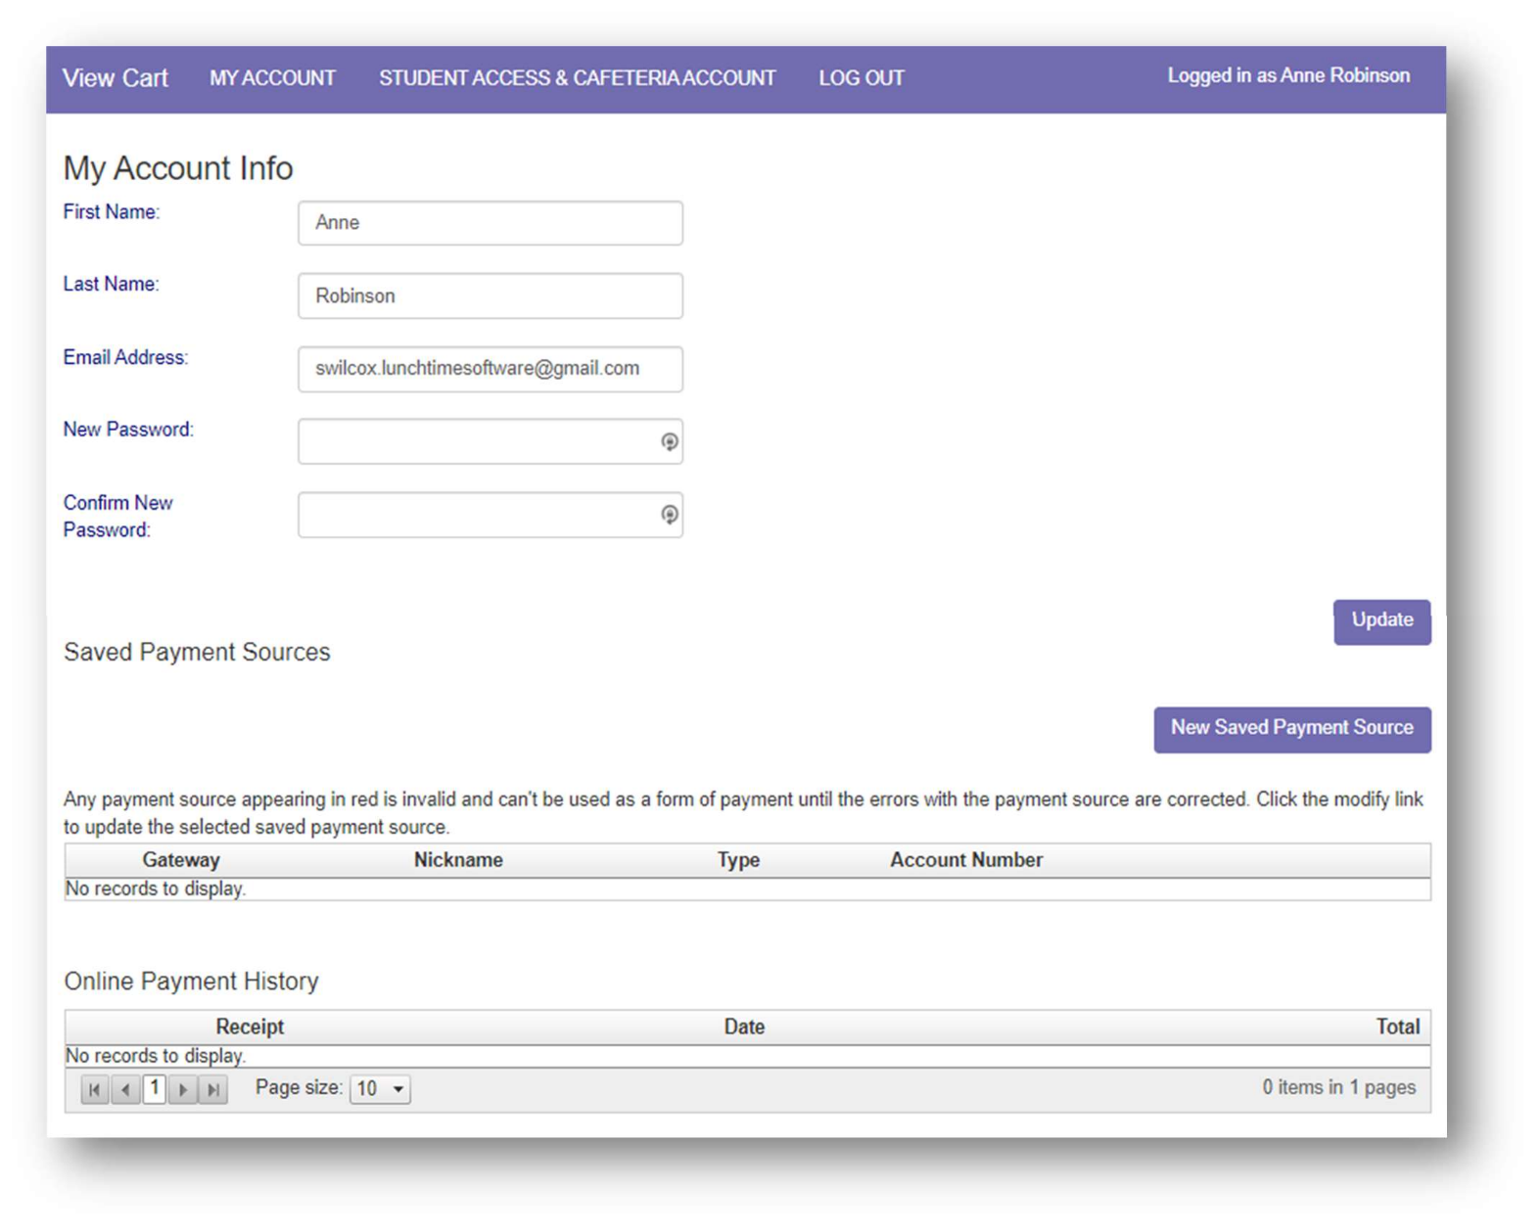

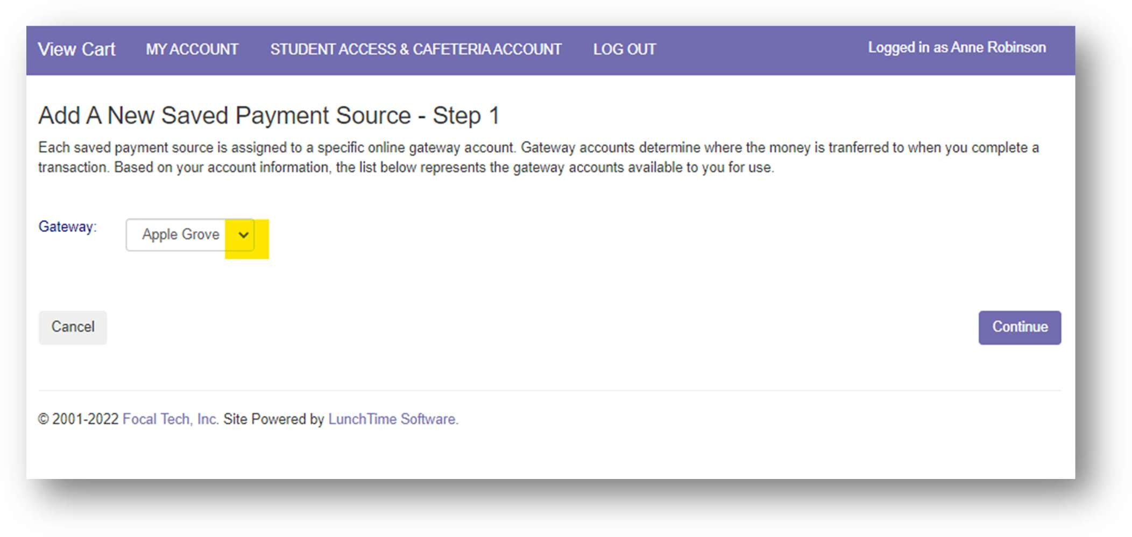
Choose the school Gateway that will receive the payments from the this payment source. Each saved payment source is assigned to a specific online gateway account. Gateway accounts determine where the money is transferred to when you complete a transaction.

Saved Payment Source – ACH (Checking or Savings Account):
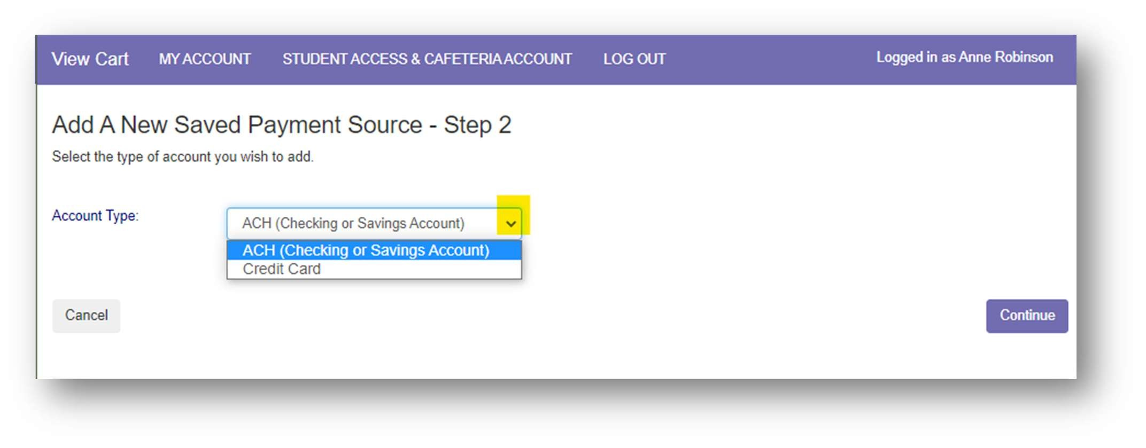
Select ACH (Checking or Savings Account) from the dropdown list Click Continue

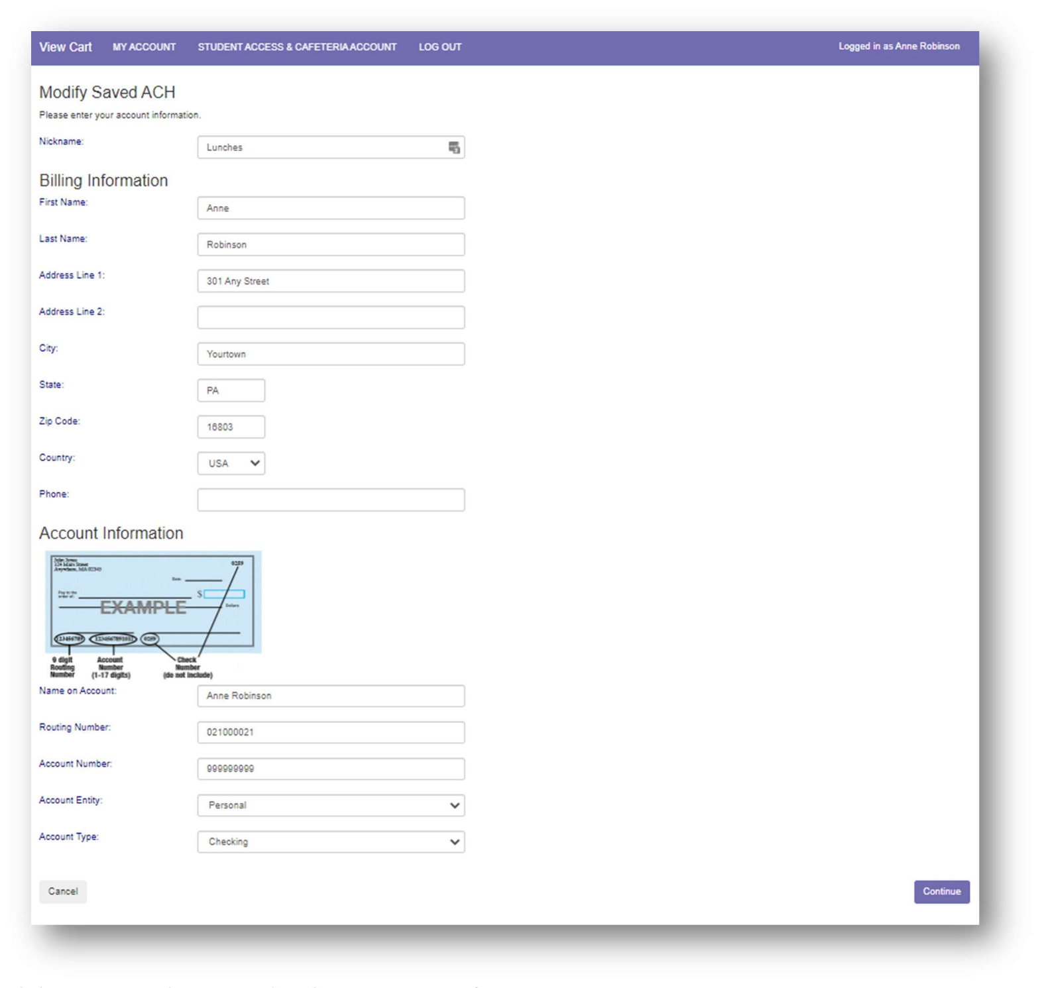
Enter your account information. The Nickname will be used to identify this card in your saved payment list.

Click Continue to be returned to the My Account Info page

Your payment source will be listed under Saved Payment Sources. Click Modify to update account information and follow the Step 3 on the previous page. If adding more saved payment sources, click the New Saved Payment Source button and follow Steps 2 and 3 of the pages above.
(If you wish to remove a saved payment source, you’ll first need to remove the auto replenish
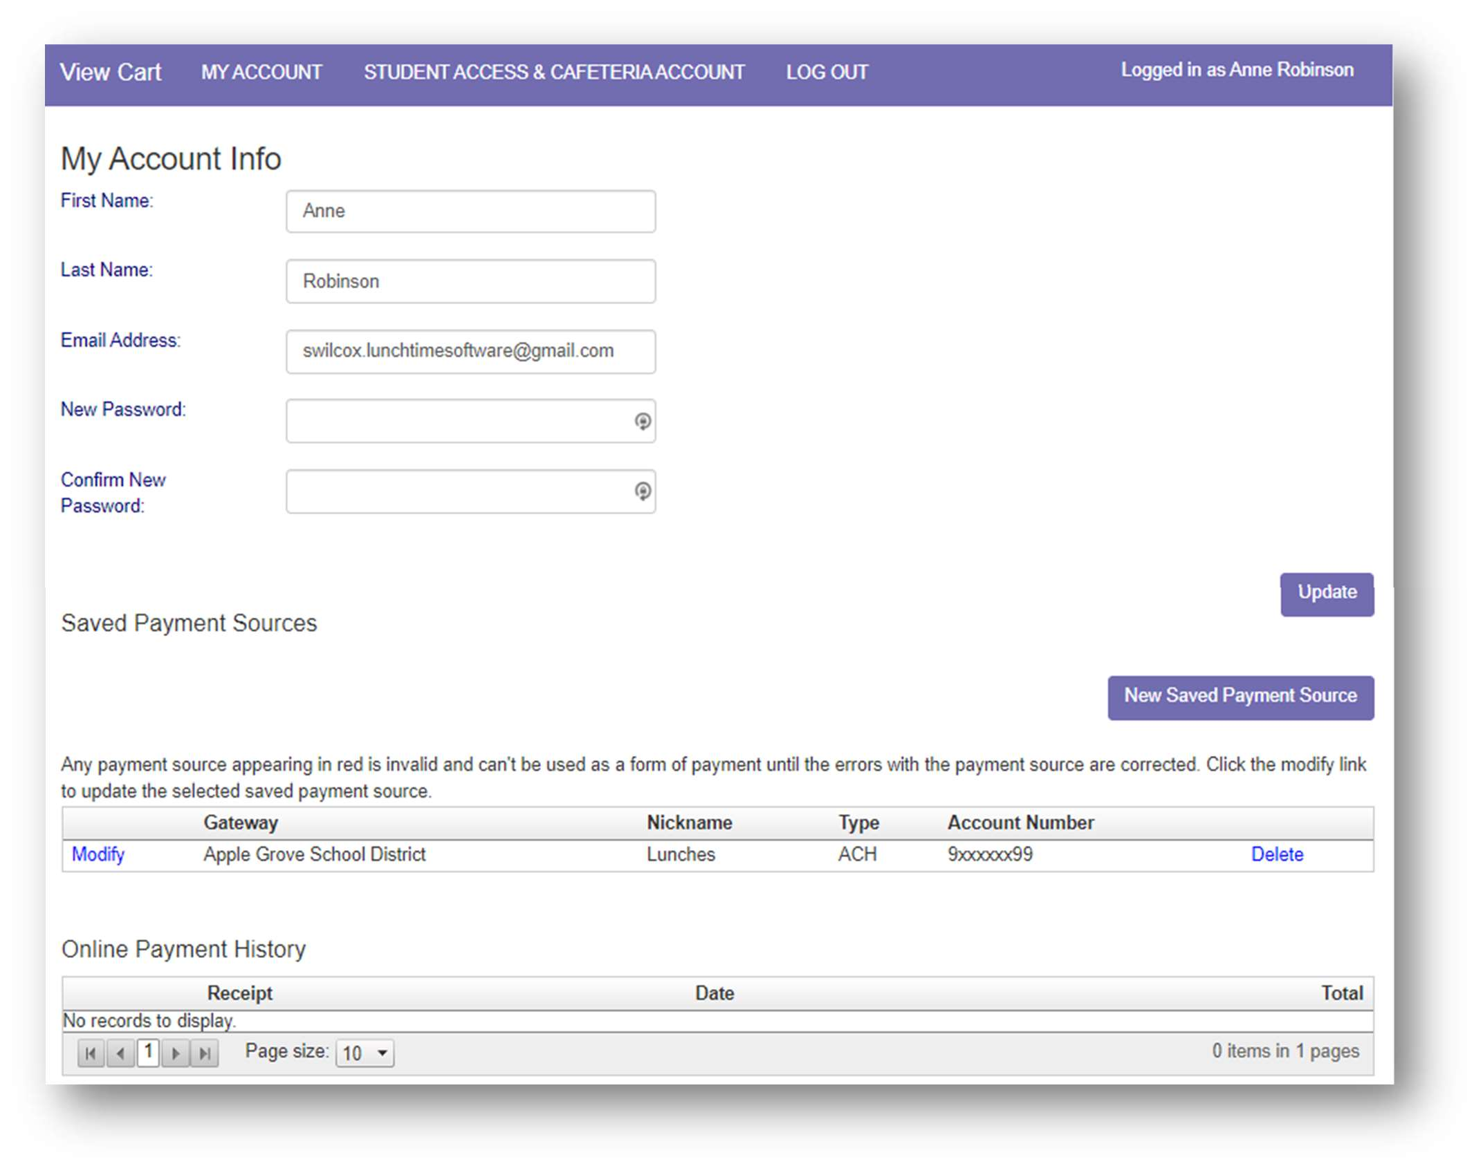
that is assigned to that payment source. Then remove the payment source.)

Click Continue

Saved Payment Source – Credit Card:
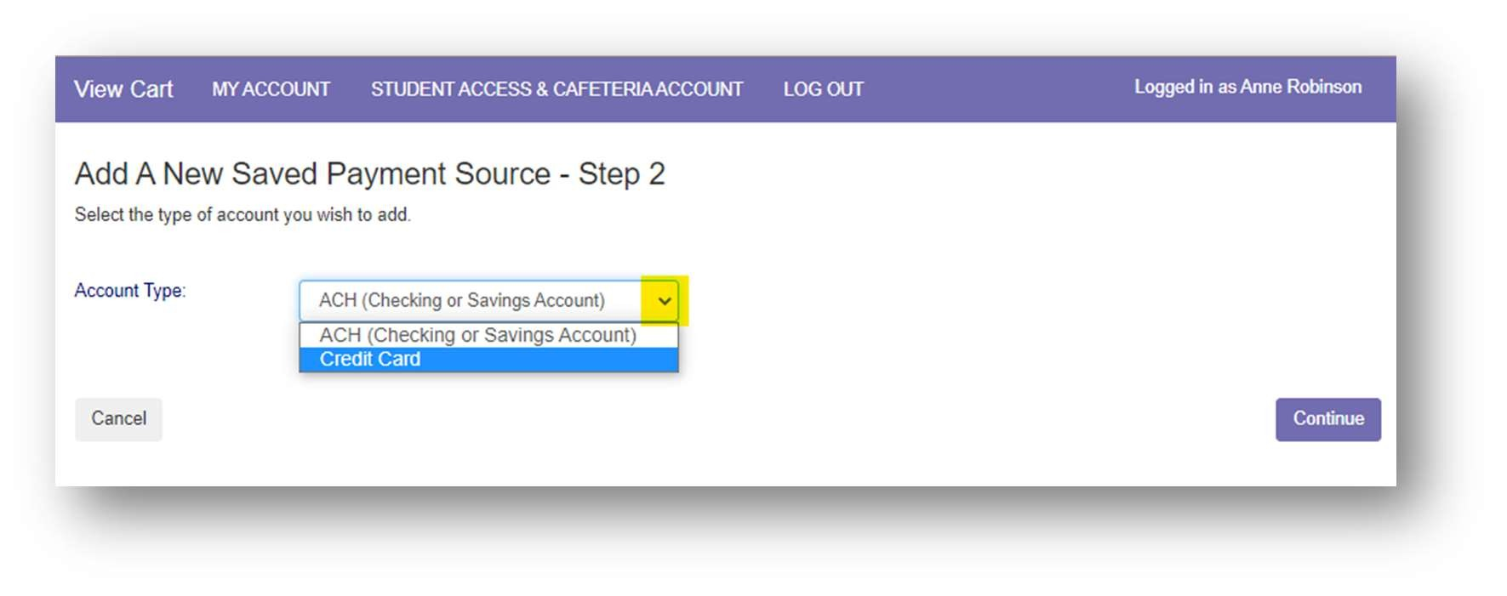
Select Credit Card from the dropdown list.

Click Continue

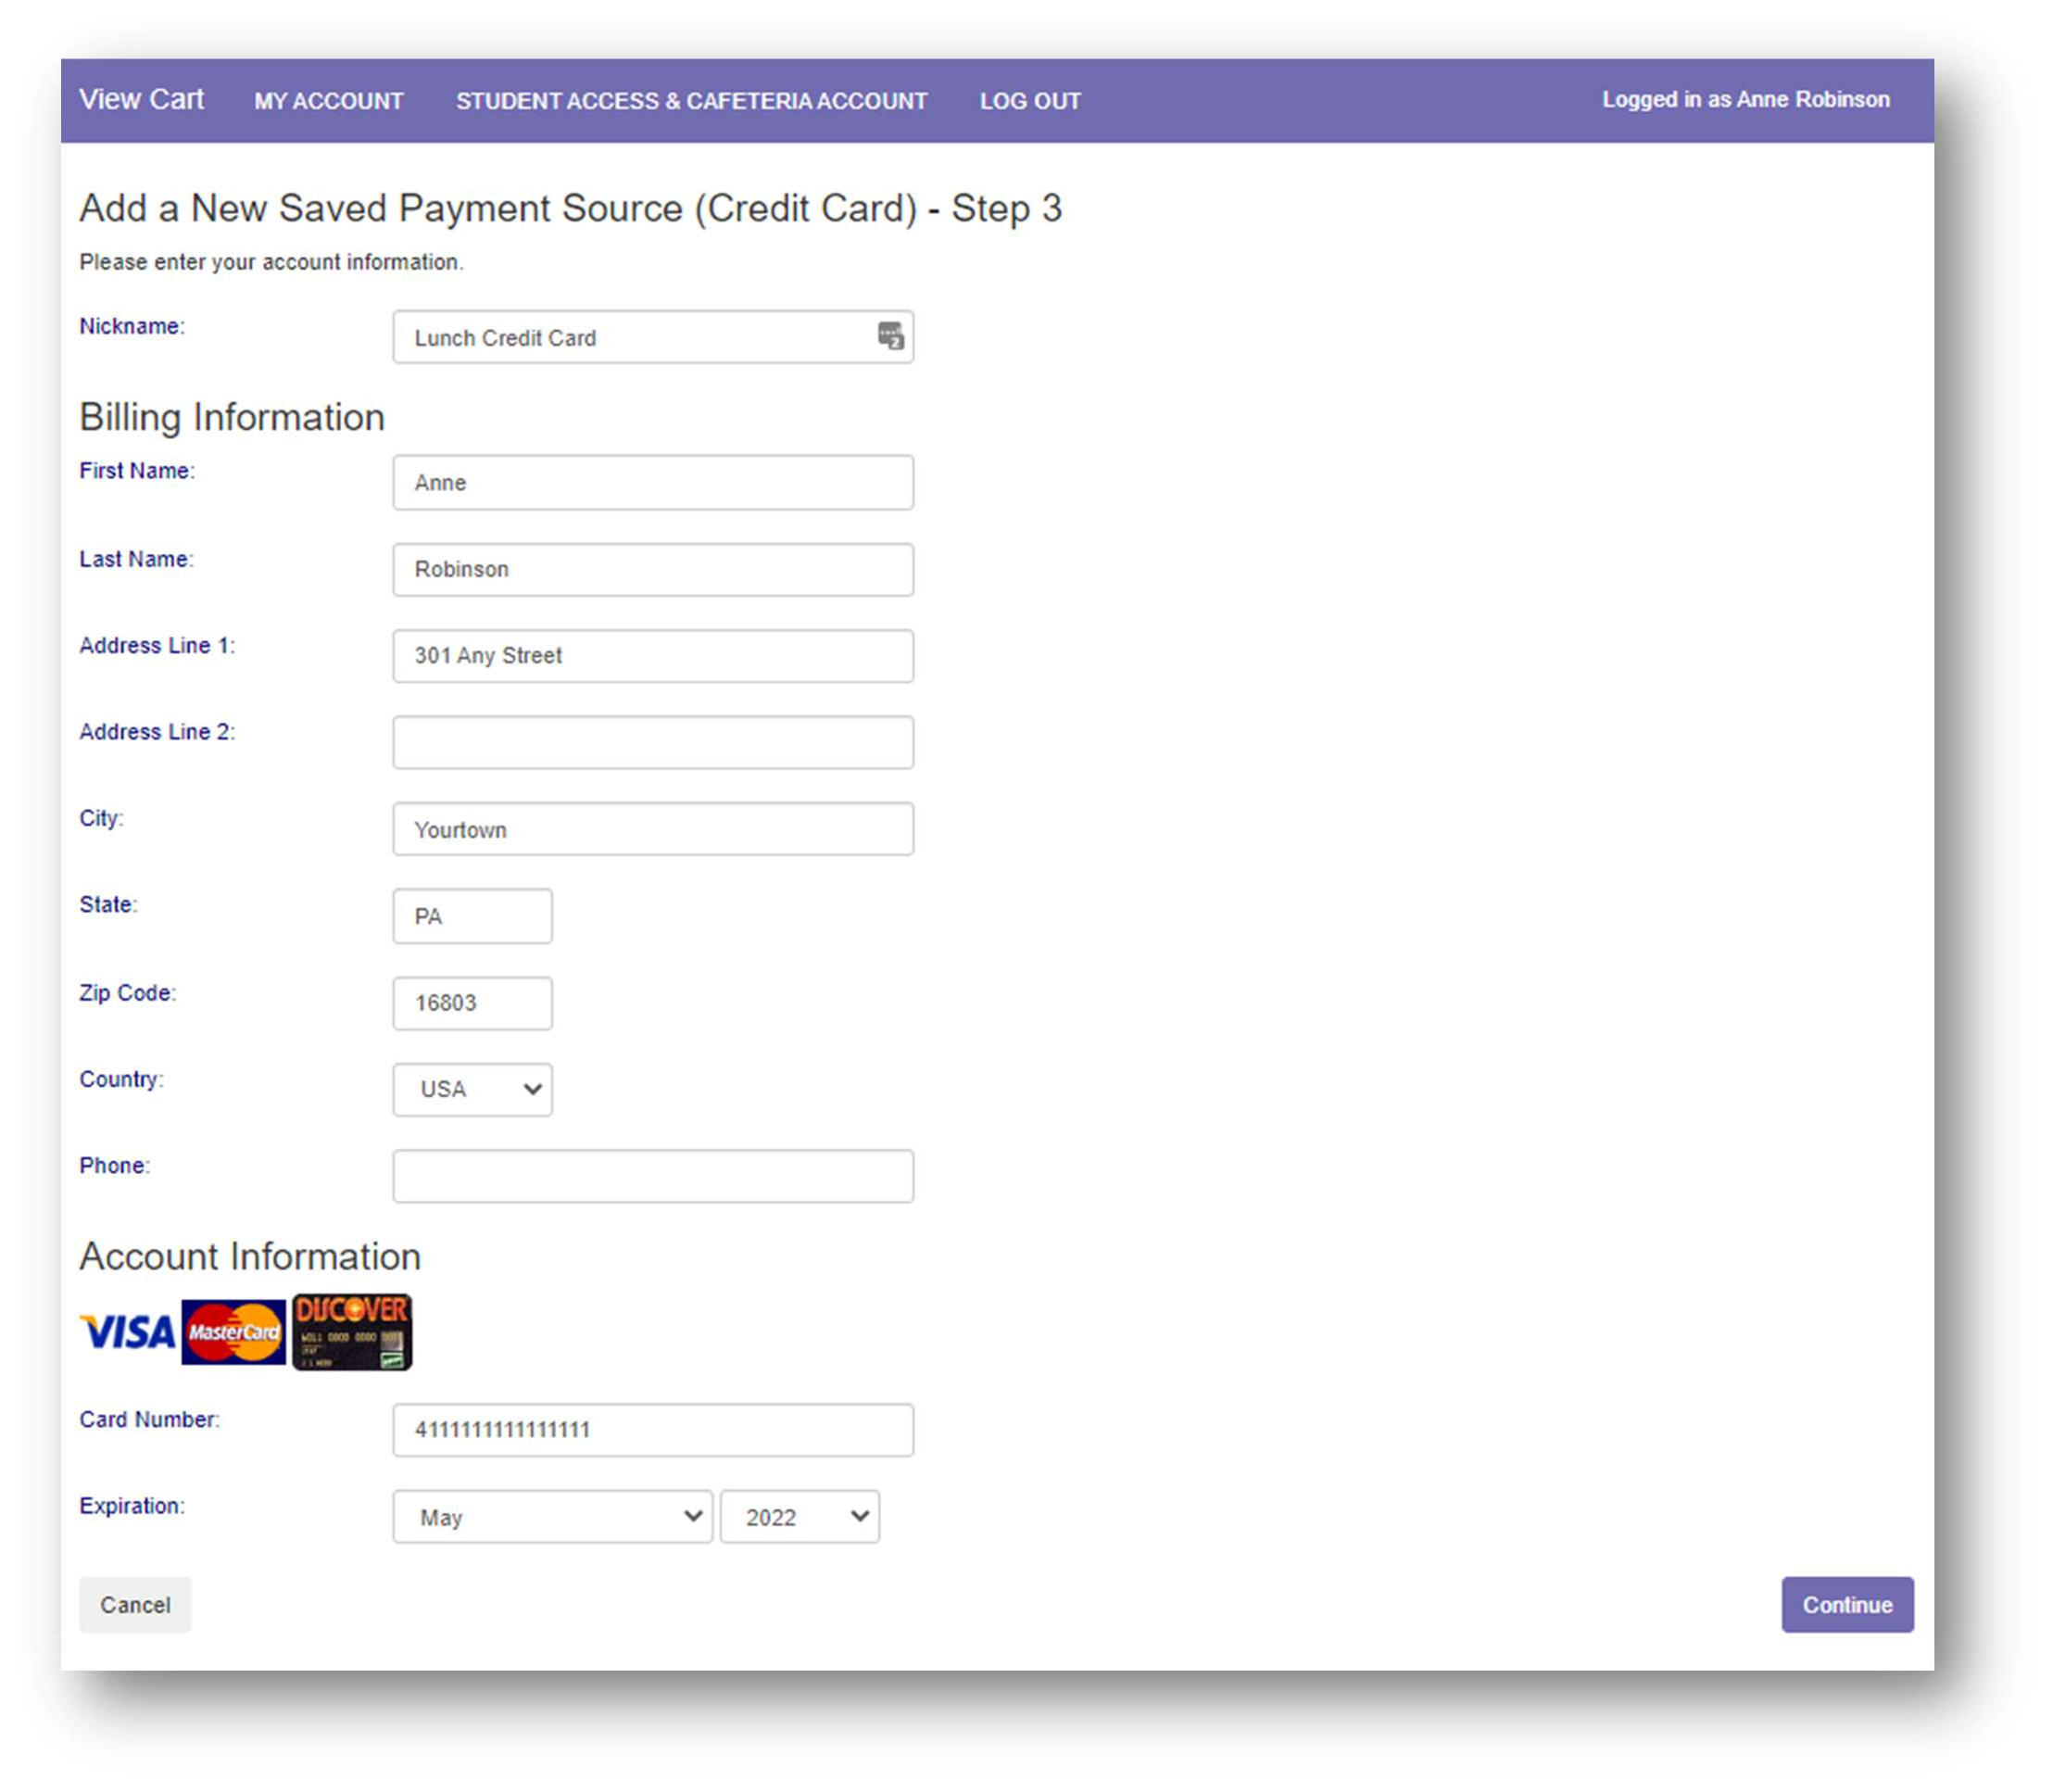
Enter your account information. The Nickname will be used to identify this card in your saved payment list.

Click Continue

Make a Cafeteria Deposit
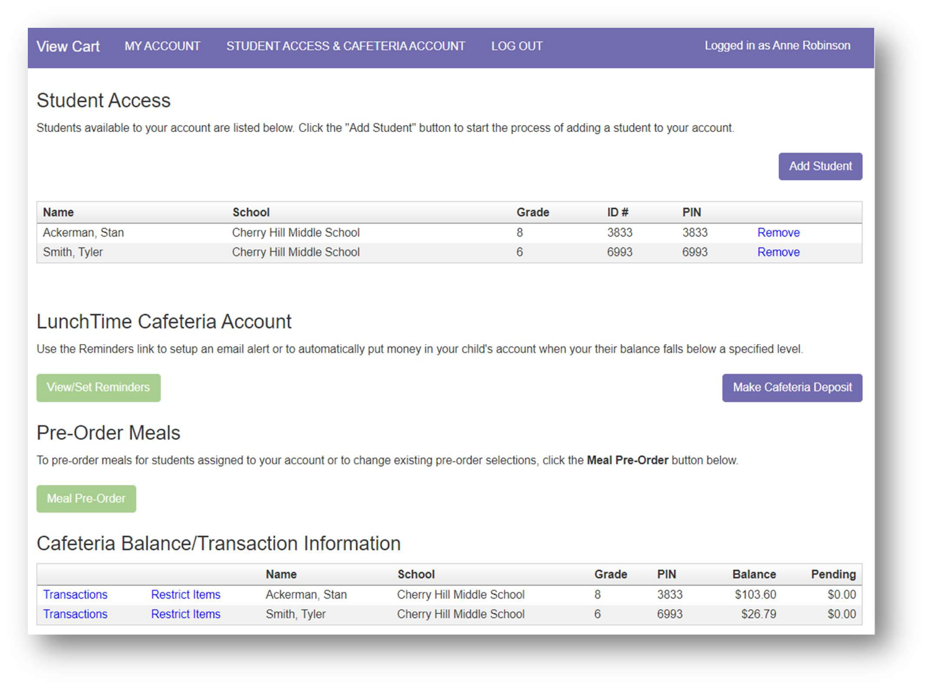
From the Student Access page, click the Make Cafeteria Deposit button.

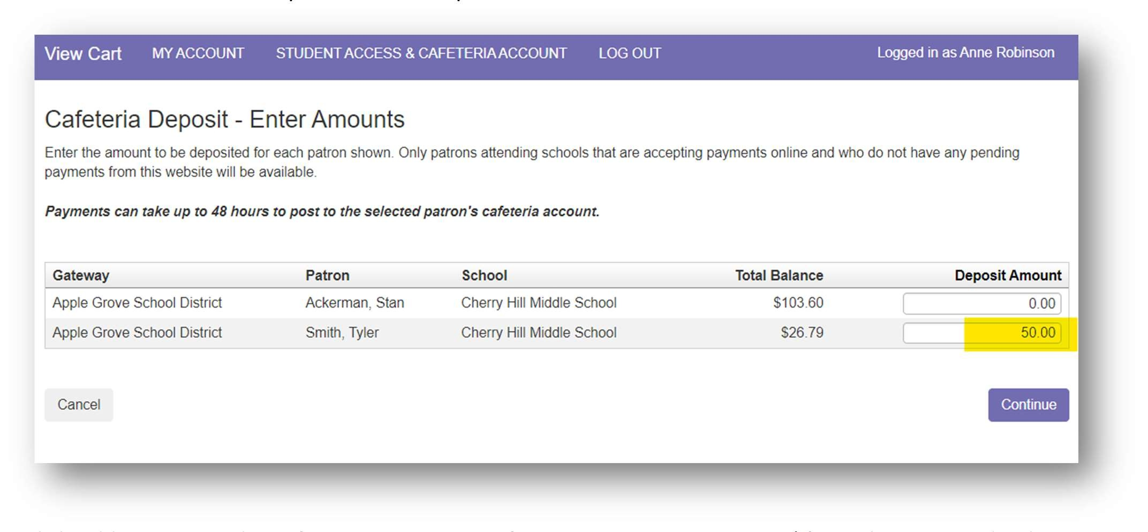
Enter the amount to be deposited for each patron as needed and click Continue.

Click Add To Cart on the Cafeteria Deposit – Confirmation page to continue. (If any changes need to be made, click Cancel and adjust as necessary.)
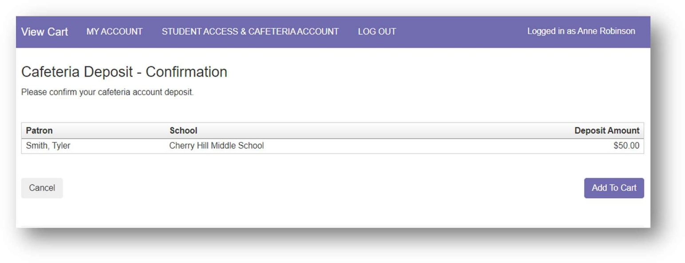

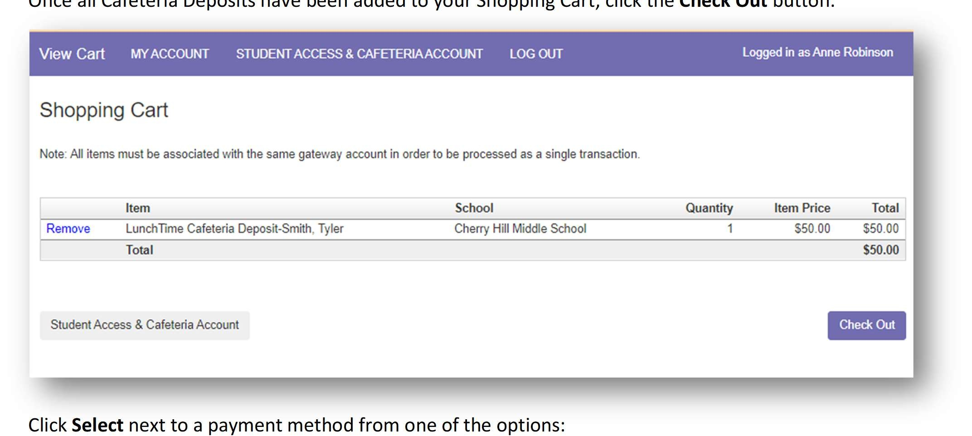
Click Select next to a payment method from one of the options:
Once all Cafeteria Deposits have been added to your Shopping Cart, click the Check Out button.

Saved Payment Source – Uses the payment source on file to pull the funds from.
One-Time Credit Card – Choose this option when using a credit card that has not been set as a saved payment source or is only being used this one time.
One-Time ACH – Choose this option when using an online checking account that has not been set as a saved payment source or is only being used this one time.
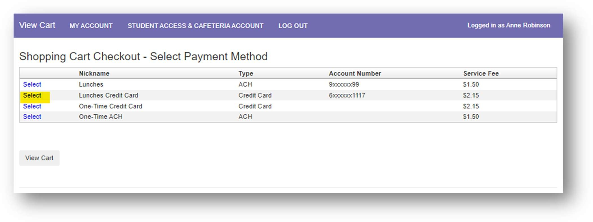

Review the payment information for accuracy, check the box confirming that you accept the fees for this transaction.
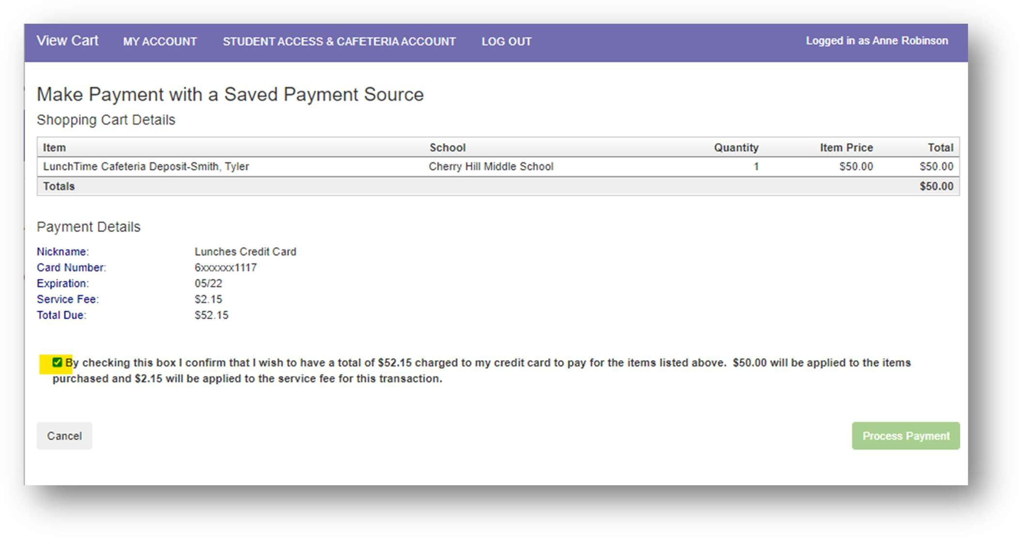
Click Process Payment

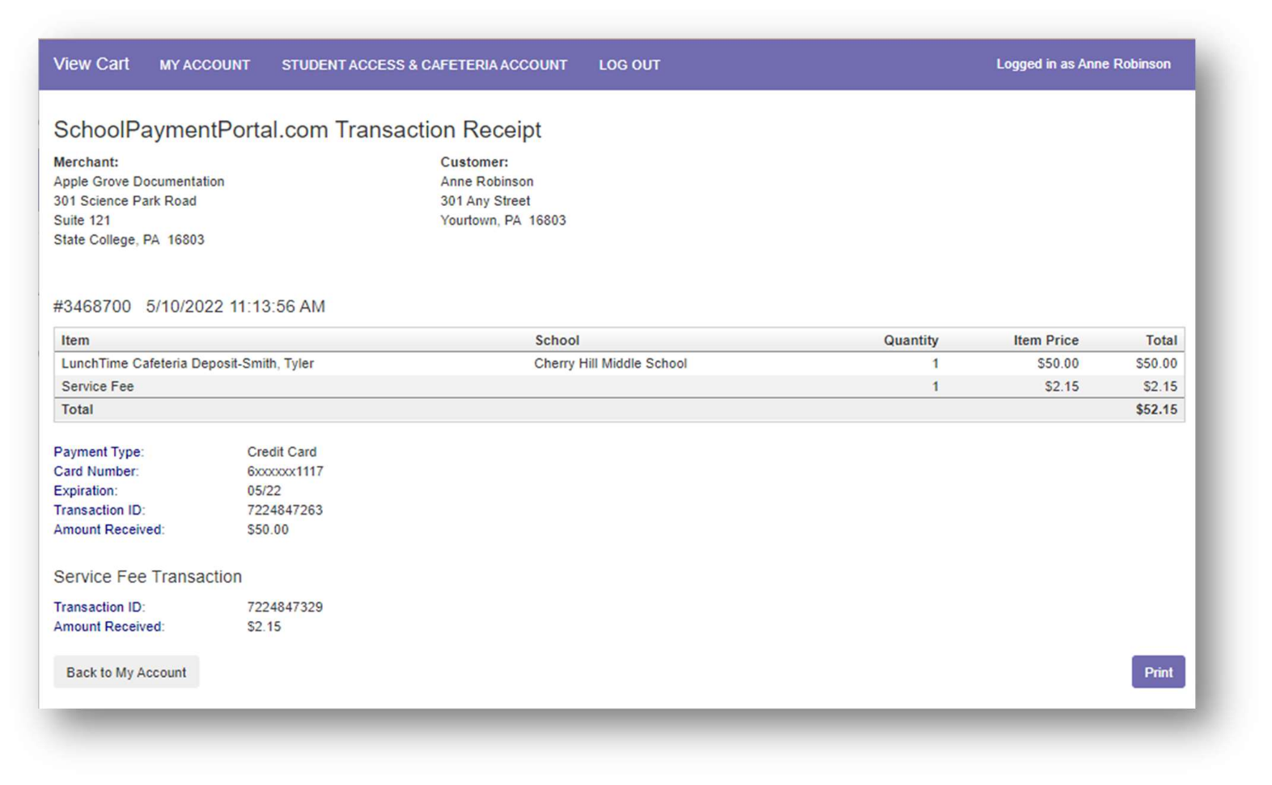
On the SchoolPaymentPortal.com Transaction Receipt page, the transaction details are listed.

If you’d like a printed receipt, click Print.

Click Back to My Account to return to the My Account Info page.

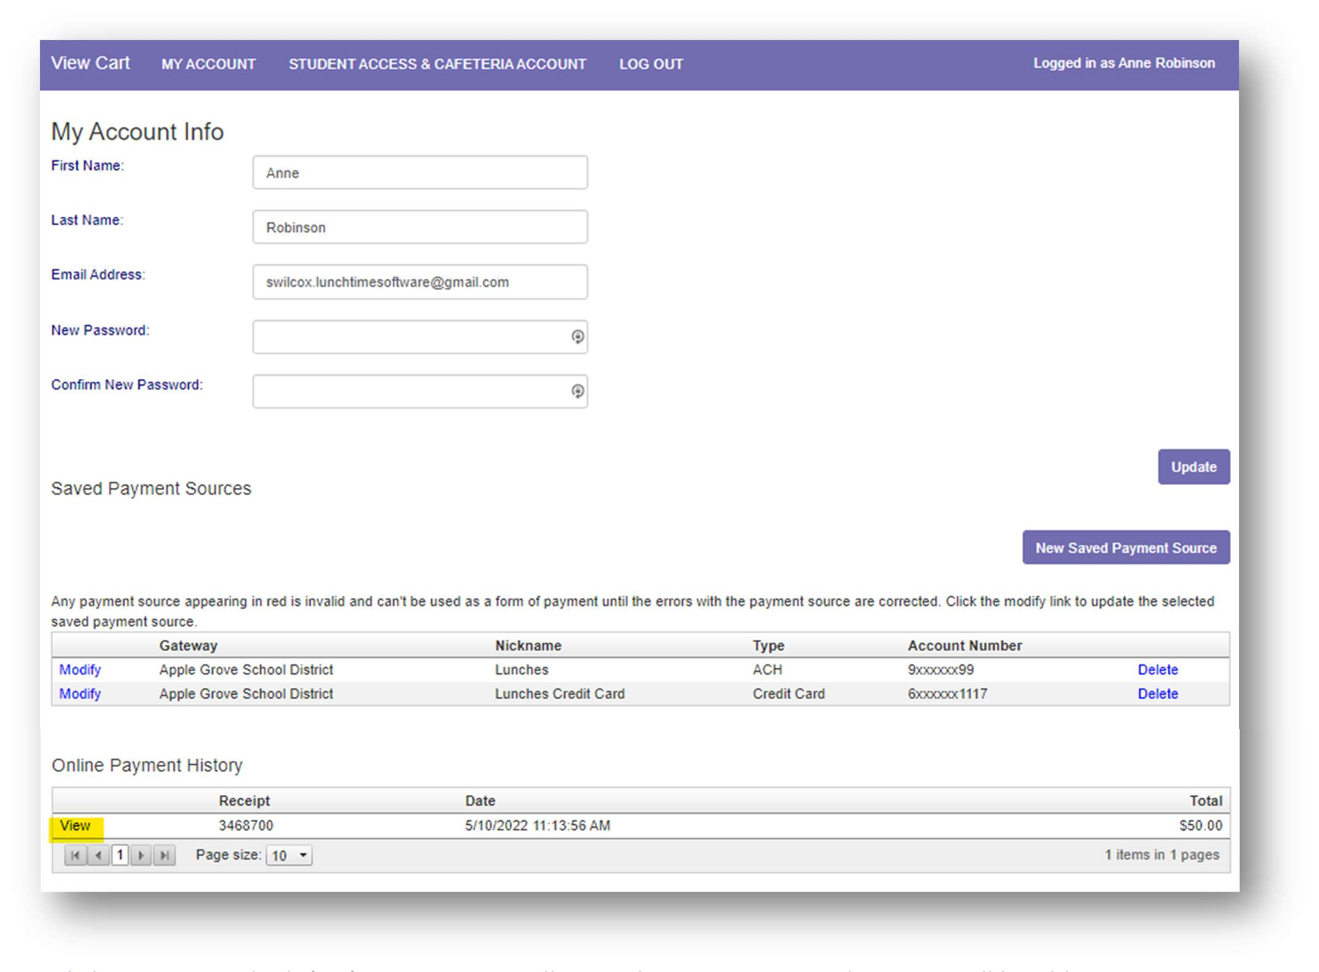
From the My Account Info page, Online Payment History, is a list of all processed payment transactions for the current school year.

Clicking View to the left of a transaction will open the Receipt page where you will be able to view and/or print any of the online payment transactions.

Setting Email Reminders/Auto-Replenish
Users can establish thresholds for each student and receive either email reminders or automatic payments when the threshold has been reached. Under the LunchTime Cafeteria Account section, Click on View/Set Reminders.
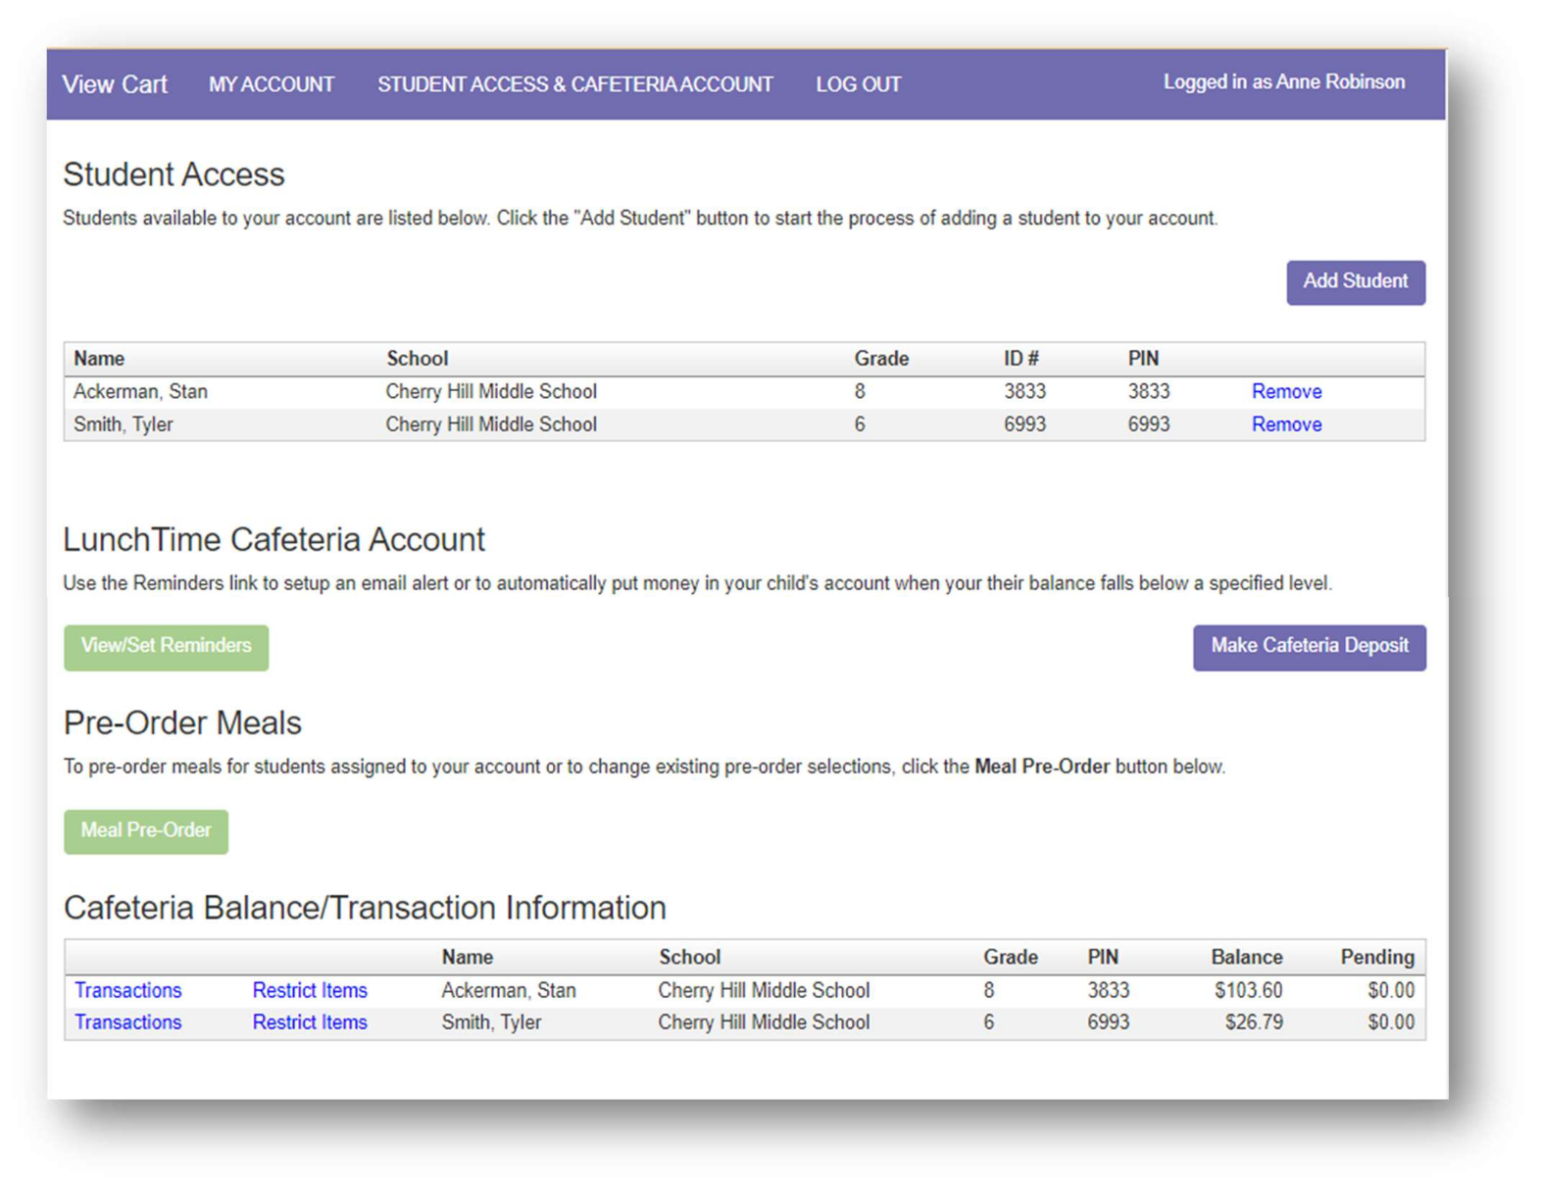

Email Reminders
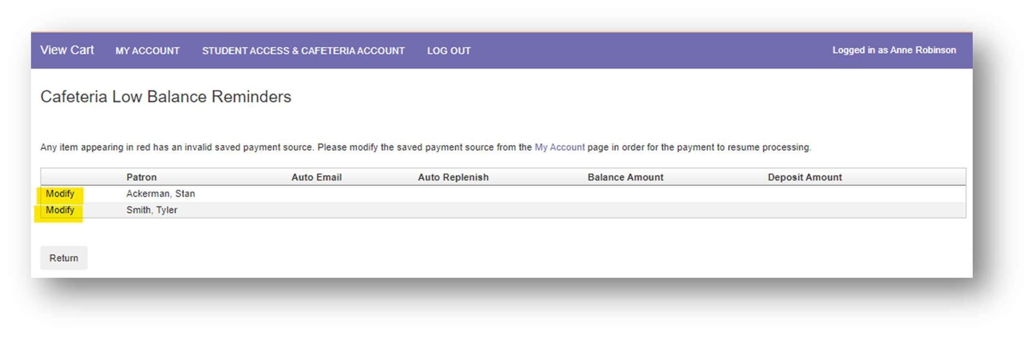
Click Modify next to the Patron name.

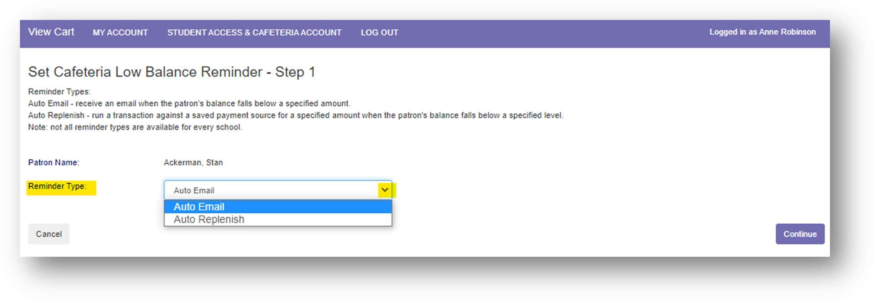
Choose Auto Email from the Reminder Type dropdown list to receive an email message when the patron’s balance falls below a specified level.
Click Continue

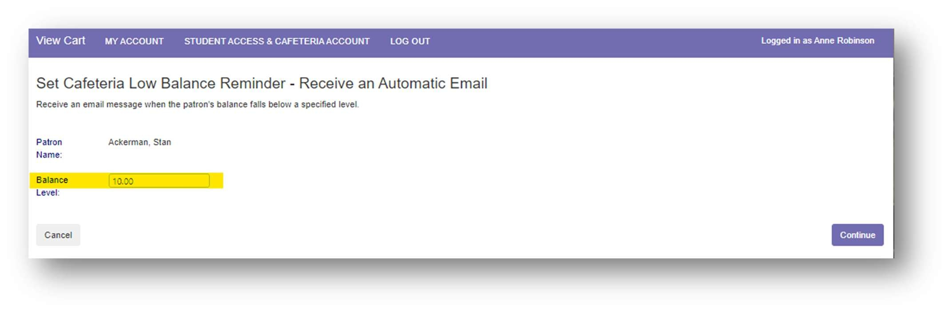
Enter the Balance Level that will trigger the Auto-Email notification.

Click Continue

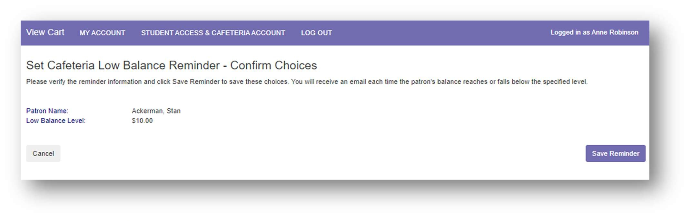
Verify the reminder information

Click Save Reminder

Auto Replenish
(You must have a saved payment source to use this Reminder Type)

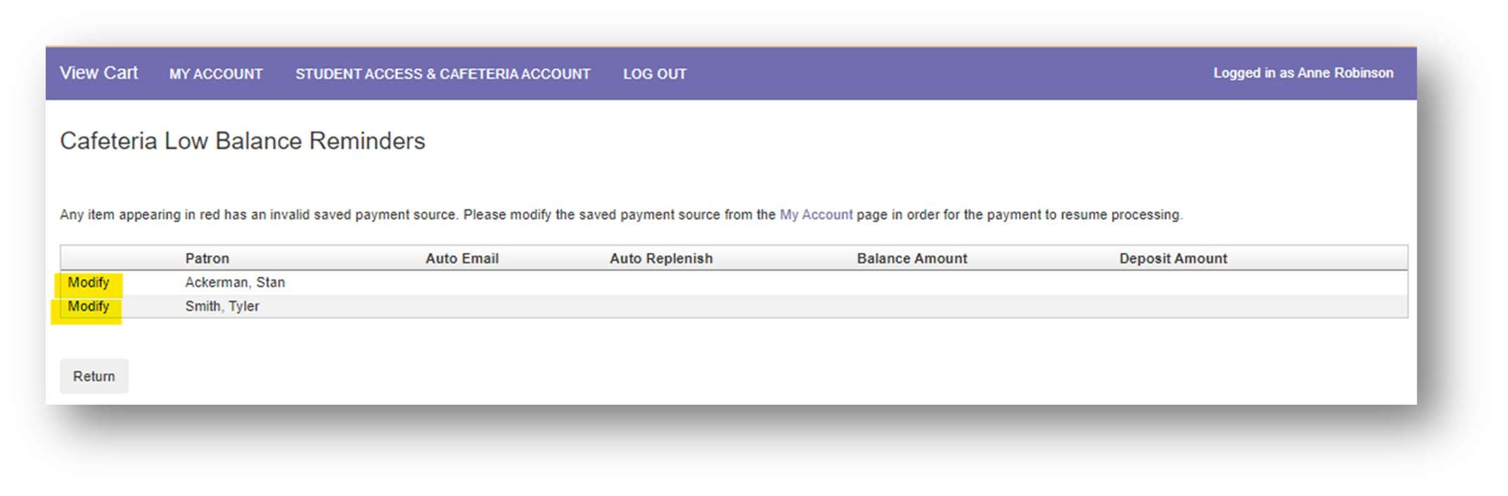
Click Modify next to the Patron name.

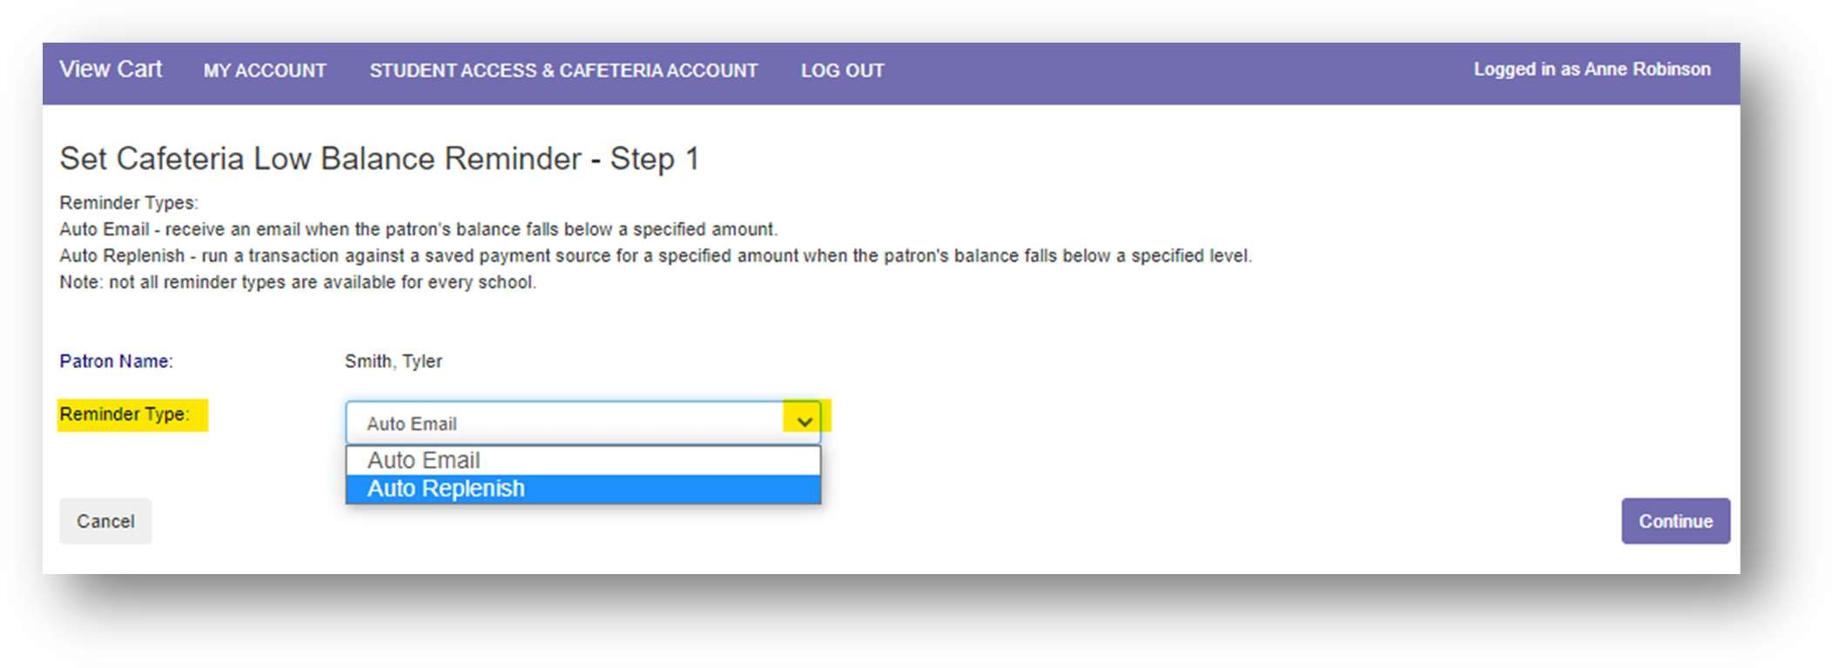
Choose Auto Replenish from the Reminder Type dropdown list to trigger an automatic deposit when the patron’s balance falls below a specified level.
Click Continue

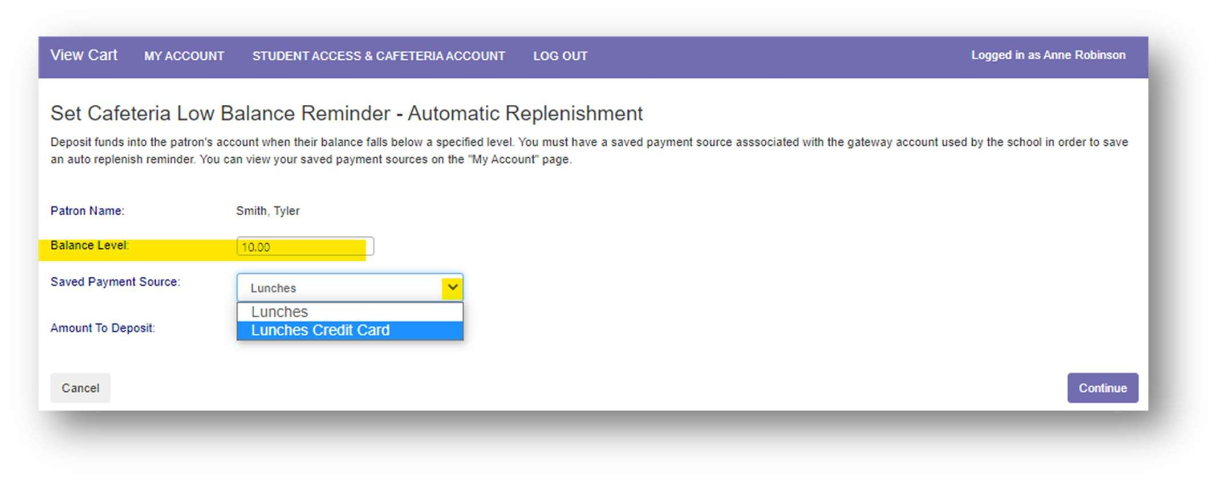
Enter the Balance Level that will trigger the Auto Replenish. Choose the Saved Payment Source to be used for the payment.

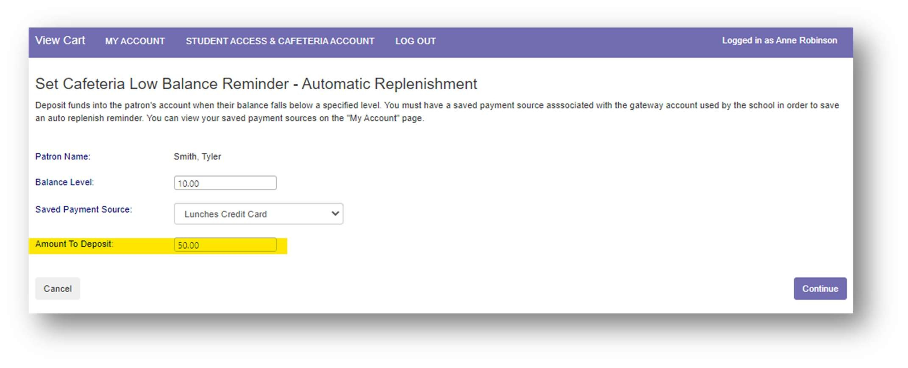
Enter the Amount to be deposited.

Click Continue

Verify the replenishment information

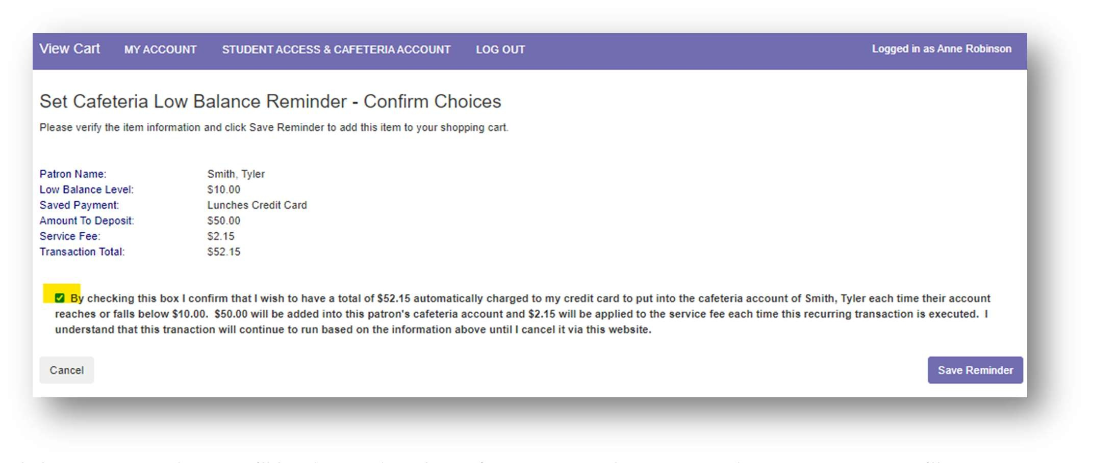
Review the payment information for accuracy, check the box confirming that you accept the fees for this transaction

Click Save Reminder. You’ll be directed to the Cafeteria Low Balance Reminders page. Here you’ll see the patron name(s) and which reminder option has been applied to each of them.
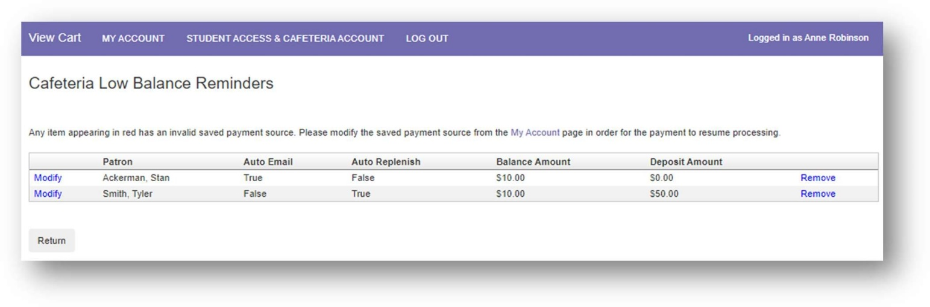
Clicking on the Return button will return you to the Student Access page.

Modifying/Removing Reminders
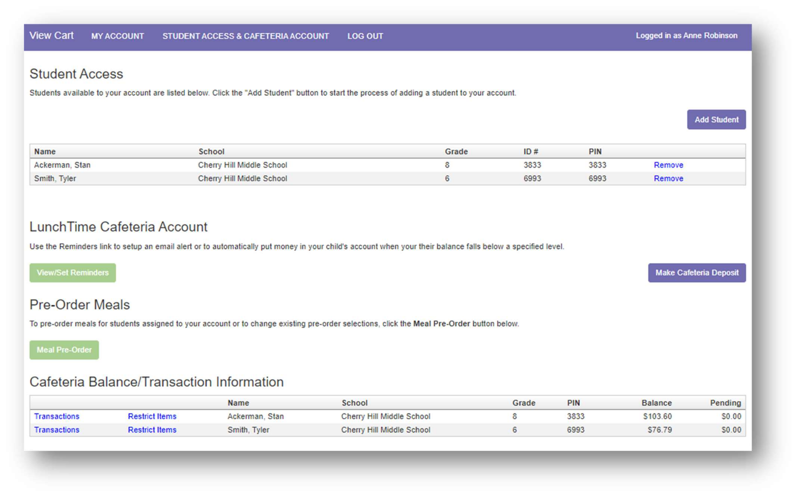
From the Student Access page, click View/Set Reminders

Click Modify to update the email reminder/auto replenish settings. Follow the steps on page 26 - 30 of this document.
Click Remove at the end of the patron row to delete the reminder.
(If you wish to remove a saved payment source, you’ll first need to remove the auto replenish
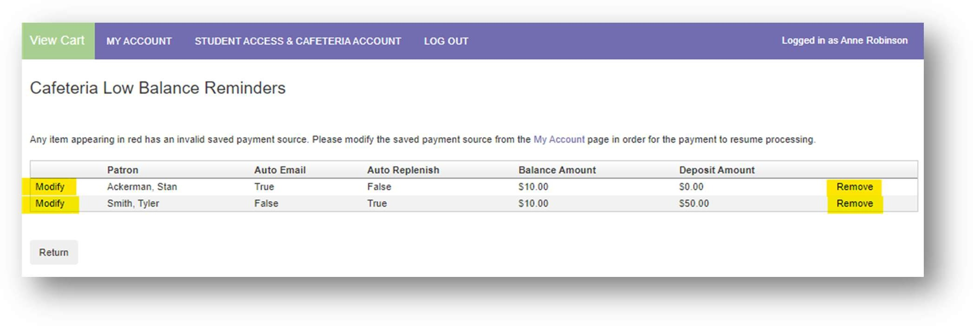
that is assigned to that payment source. Then remove the payment source.)

Meal Pre-Order
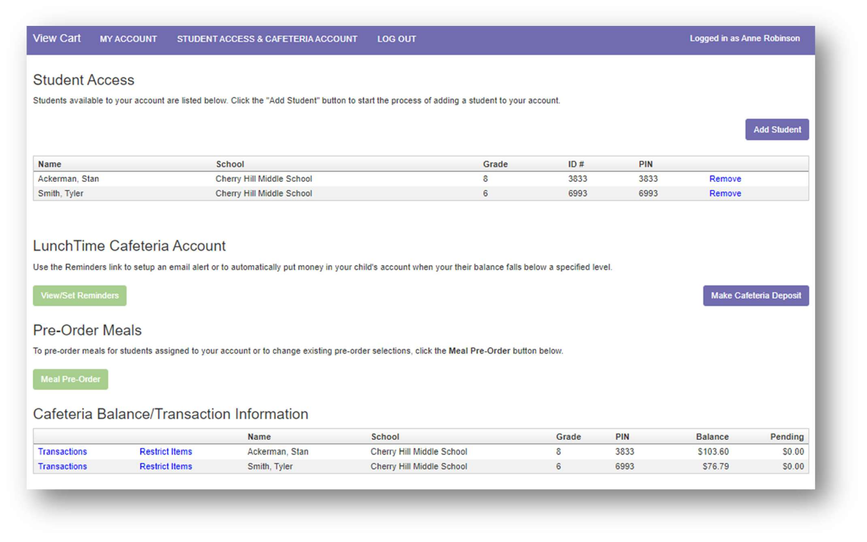
From the Student Access page, click the Meal Pre-Order button.

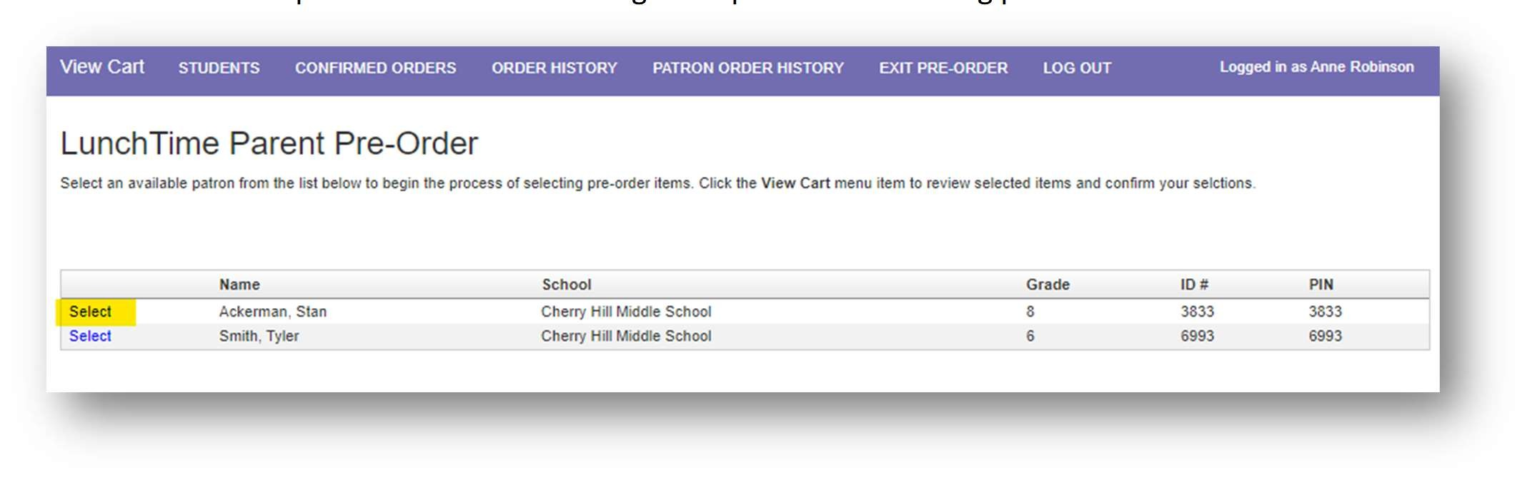
Select an available patron from the list to begin the process of selecting pre-order items.

Click Select to choose a serving day
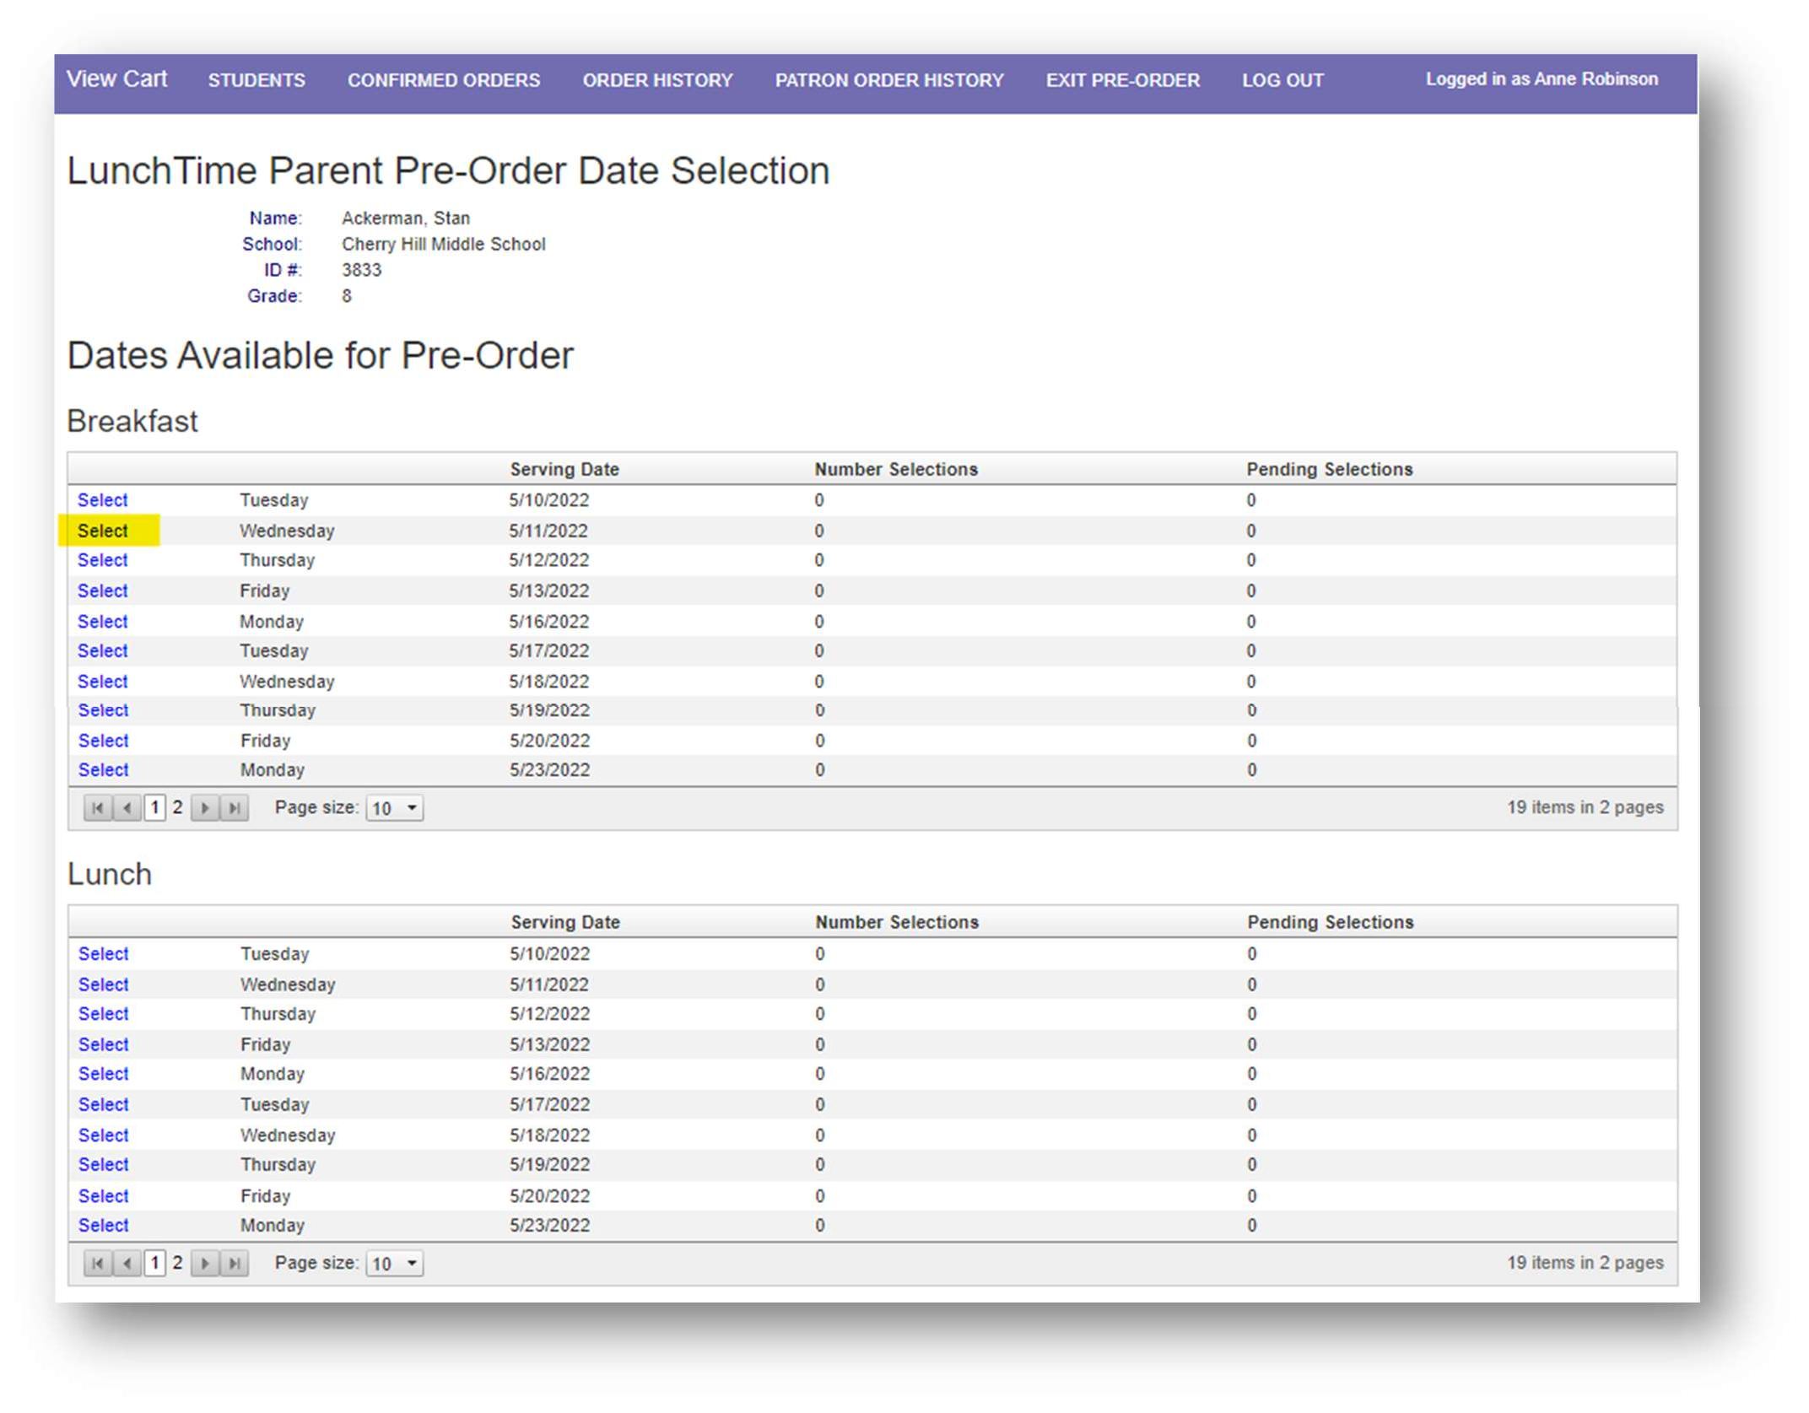

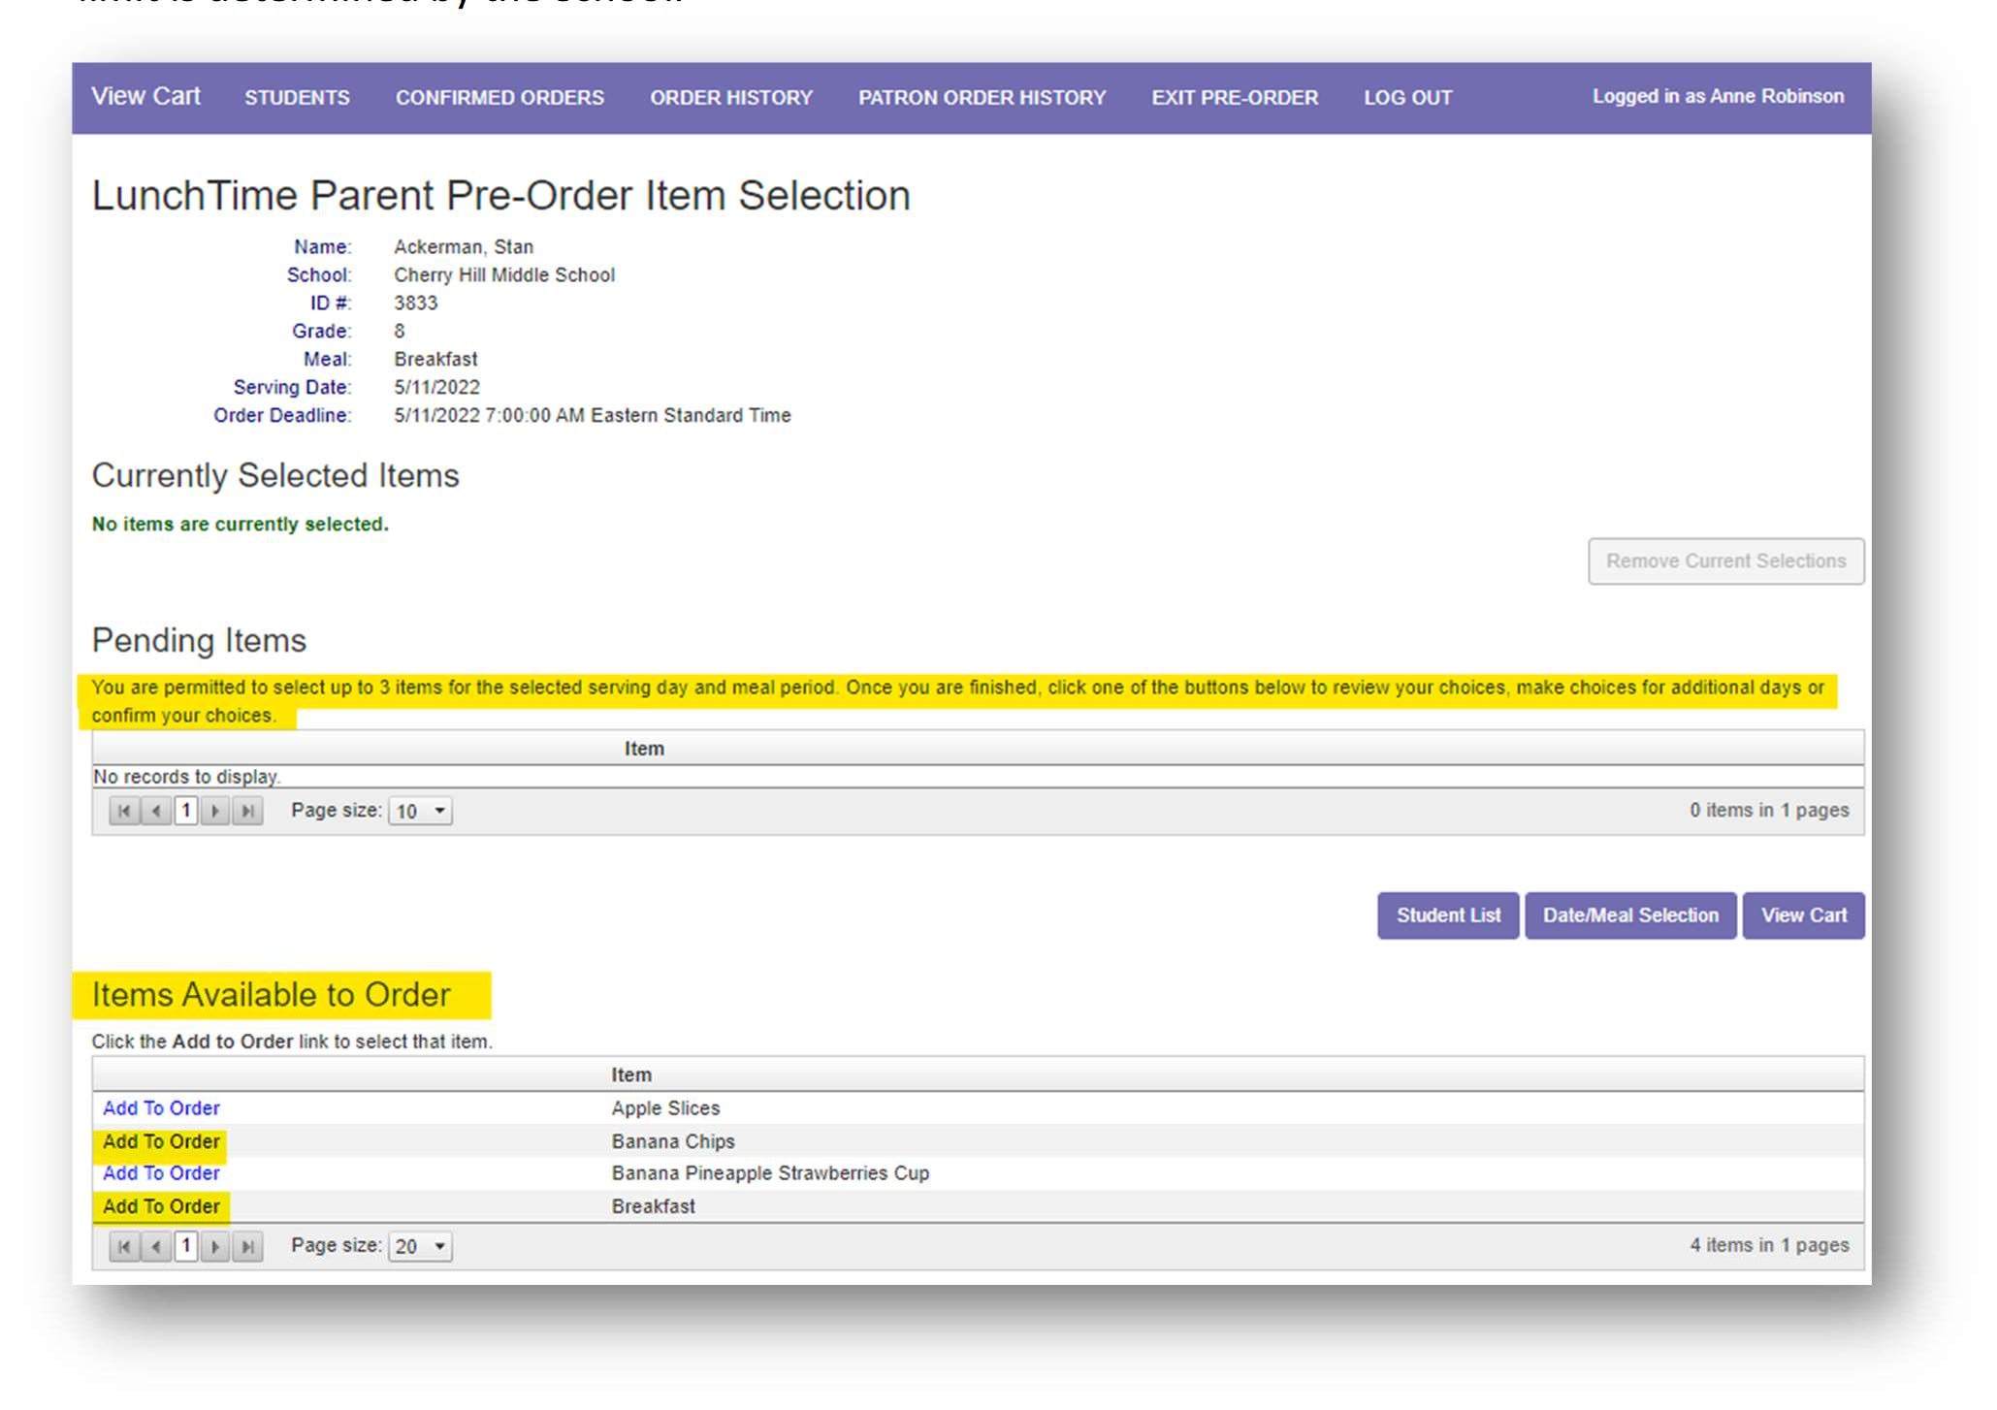
Under Pending Items you’ll find the number of items that can be selected for each meal period. This limit is determined by the School.

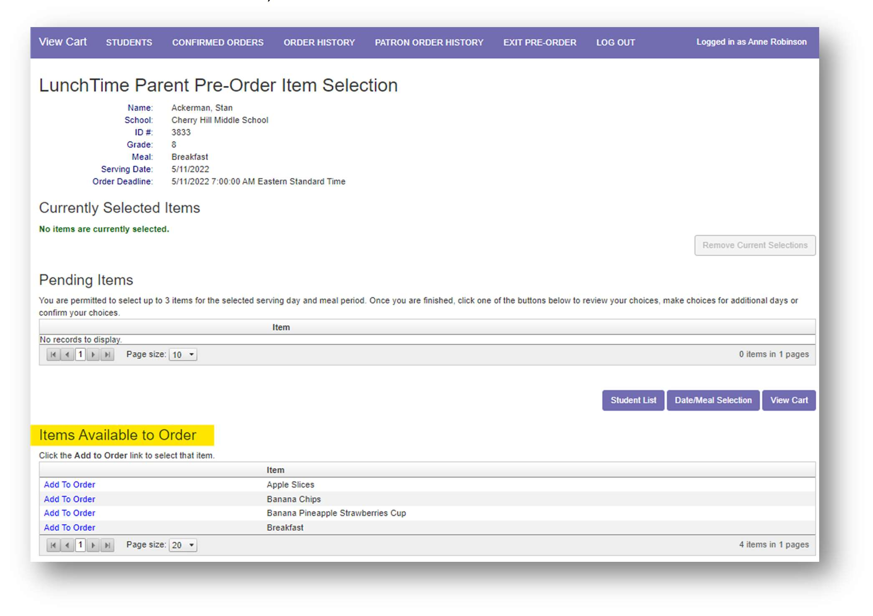
Under Items Available to Order, click Add to Order next to the item.

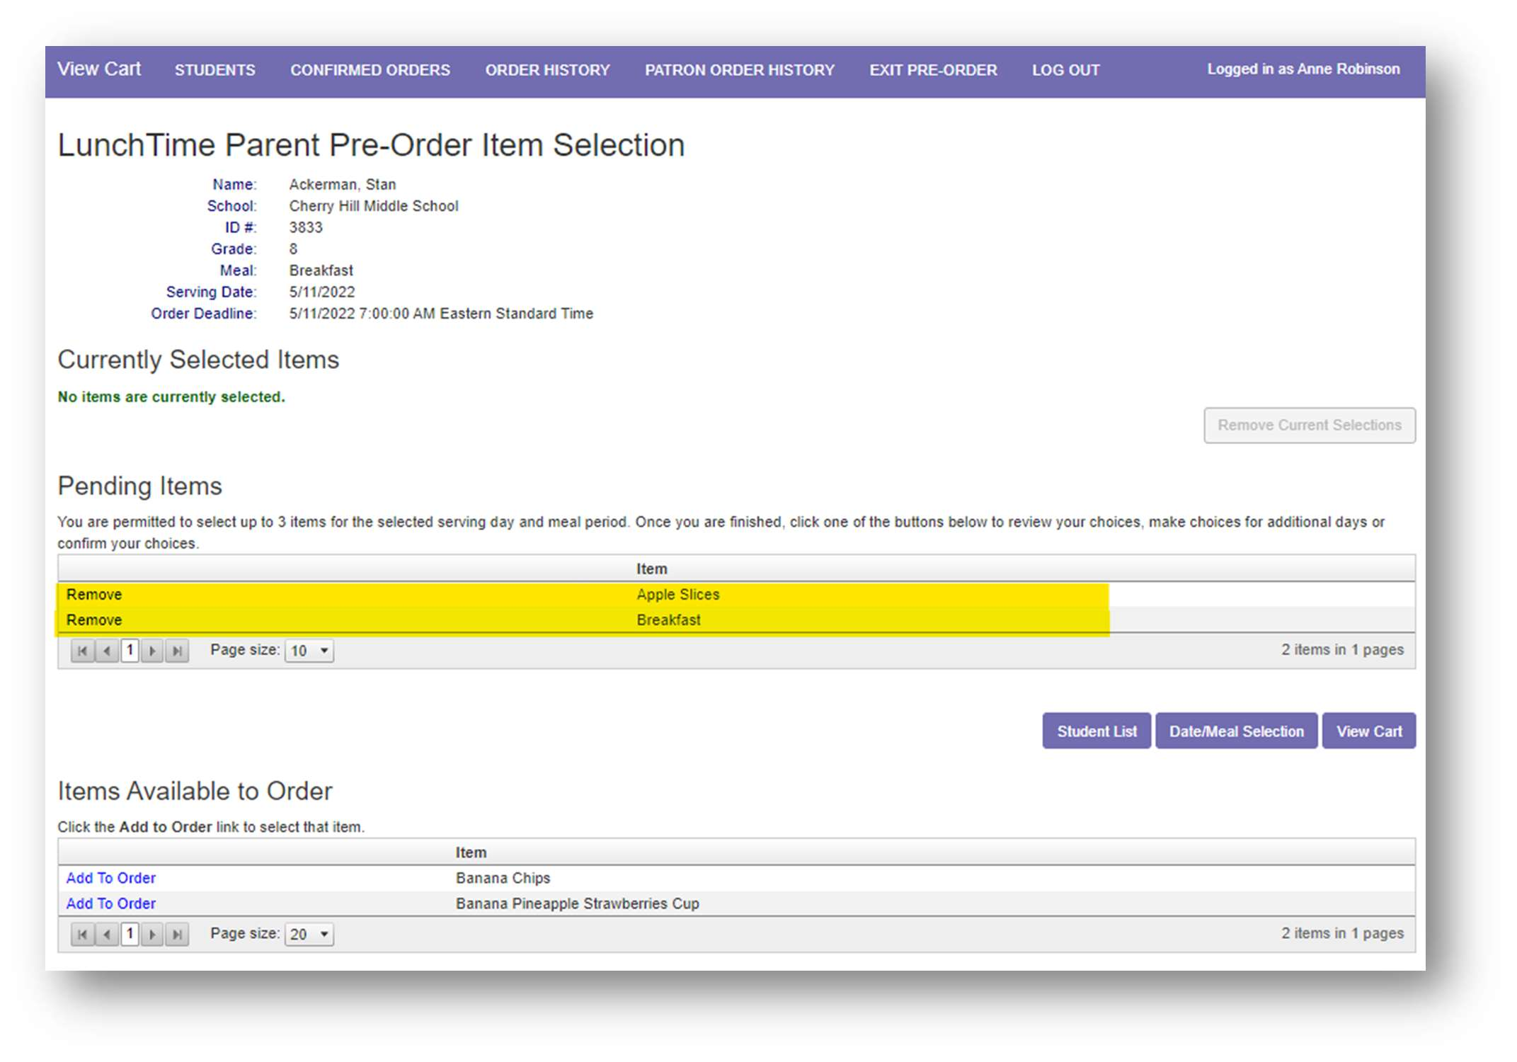
This puts the item(s) in the Pending Items section.

To Remove any item from the Pending Items list, simply click Remove next to that item. Click the View Cart button to proceed to the Pre-Order Cart.
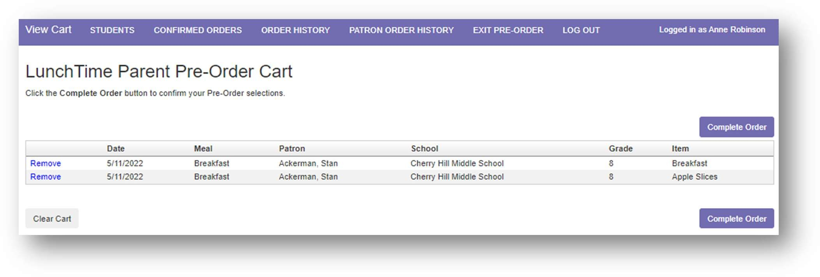
You will have one more option to remove any of the items. Once the correct items are in the Pre-Order Cart, click the Complete Order button to confirm the selections.

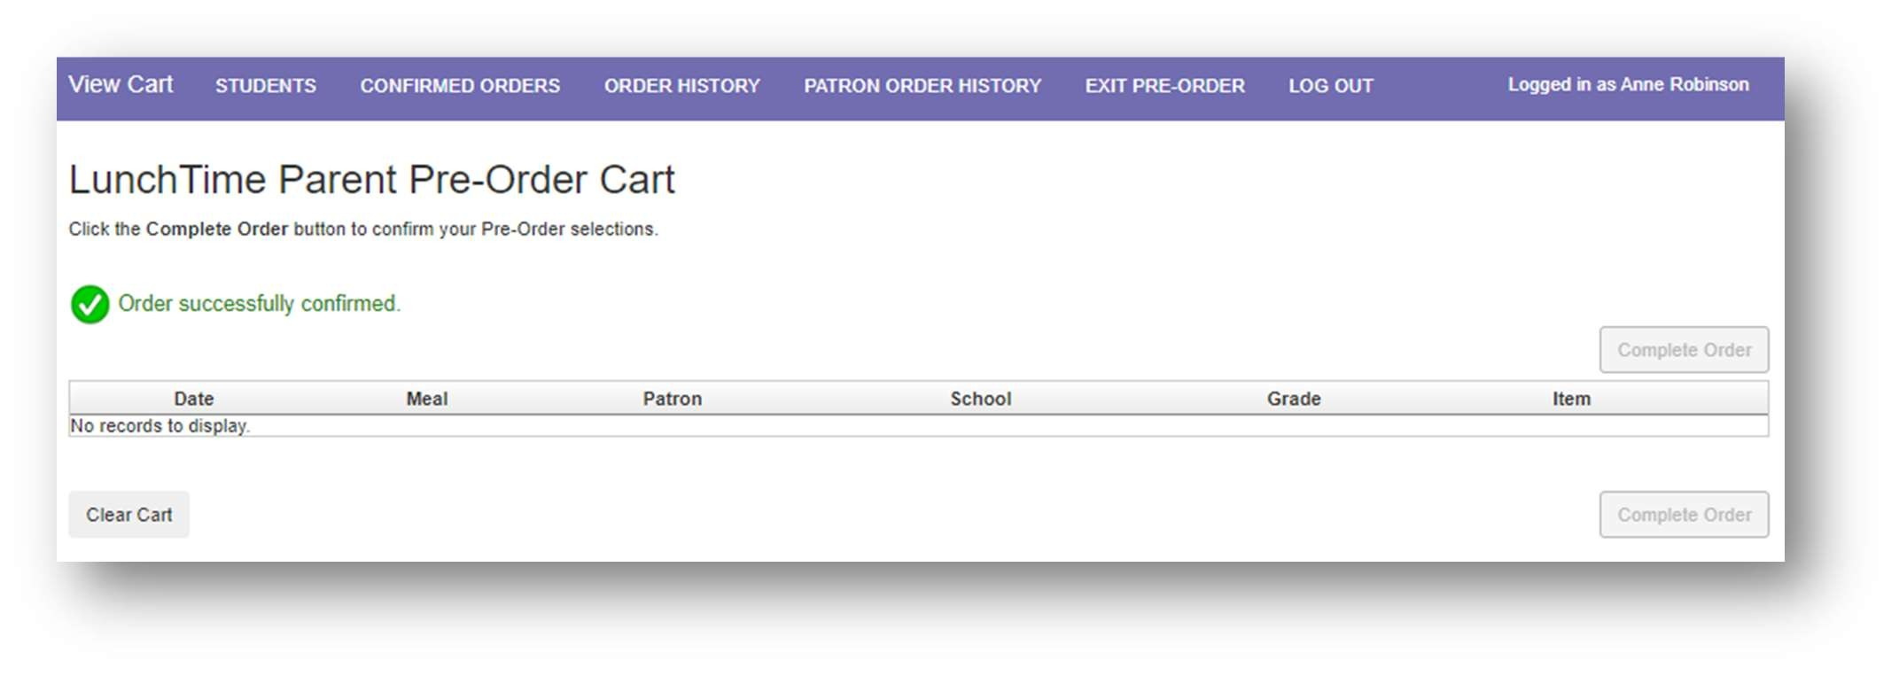
You’ll receive a message when the order process has been completed.

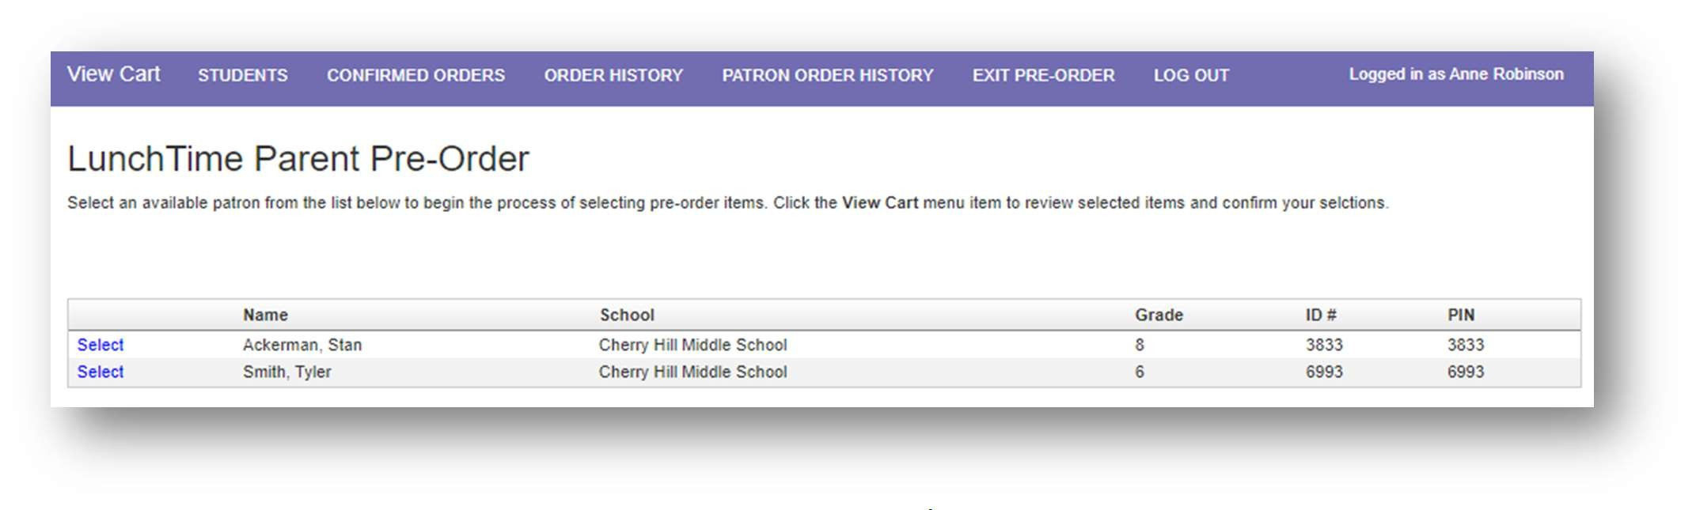
To pre-order for more students/patrons or for multiple meal periods, click STUDENTS in the Menu Bar at the top of the screen to return to the LunchTime Parent Pre-Order page.

Continue following the steps on pages 32-37 for each student/patron for each meal period.

Confirmed Orders
To view a list of previously submitted Pre-Orders, click on CONFIRMED ORDERS in the Menu Bar at the top of the screen.
These items can be removed up until a cutoff date/time that will be determined by the School. If Remove is blue and active, the cutoff date/time has not yet occurred.
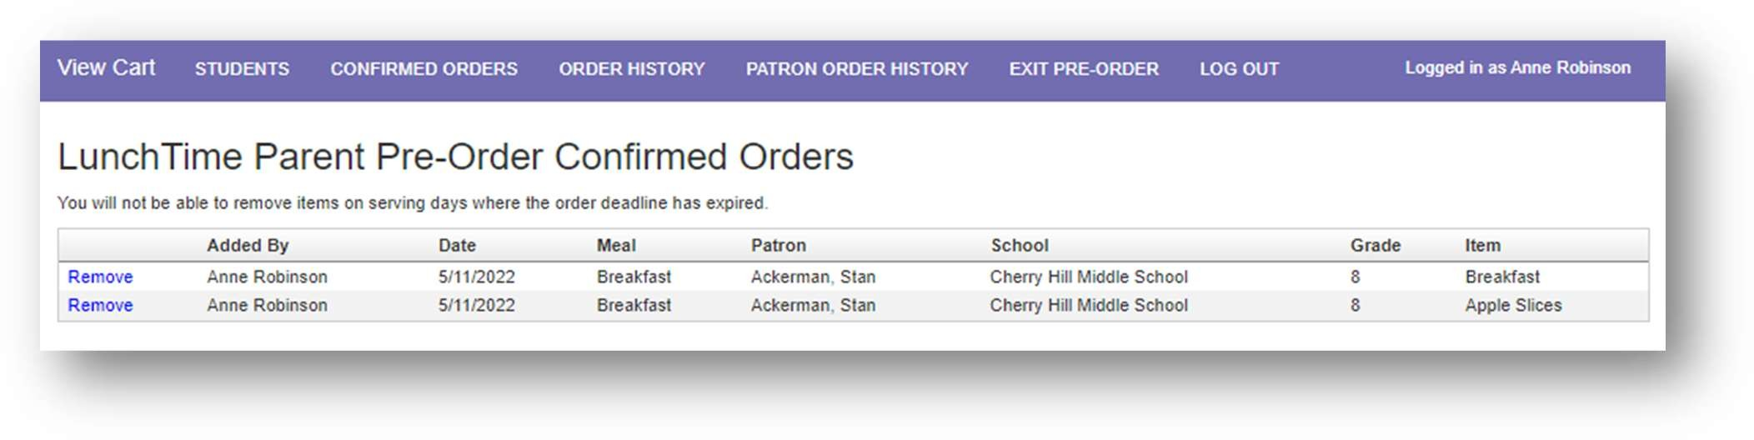

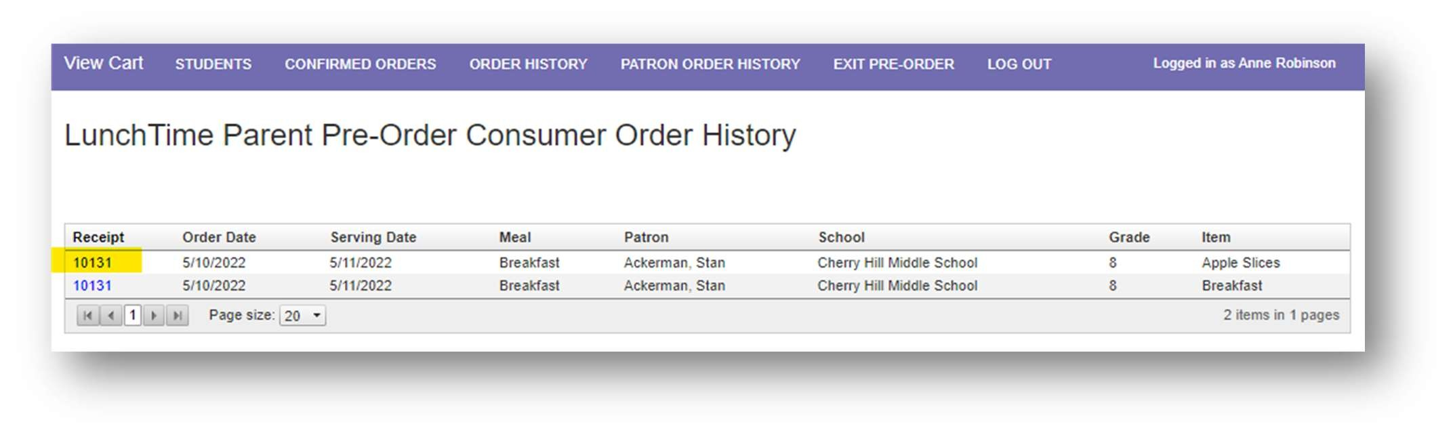
Order History
To view a list of all previously submitted Pre-Orders to date, click on ORDER HISTORY in the Menu Bar at the top of the screen.

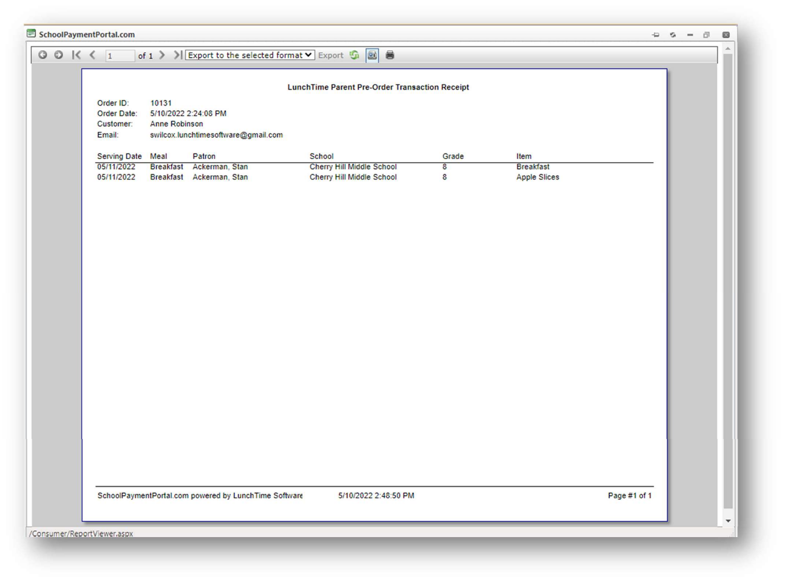
The Transaction Receipt is also available from the Order History tab by clicking on the Receipt number.

To close the Report Viewer, click on the small X above the outside scroll bar.

Patron Order History
To view a list of all previously submitted orders by Patron, click on PATRON ORDER HISTORY in the Menu Bar at the top of the screen. Choose a patron from the dropdown list to view both Items that have been ordered and items that have been deleted. This list displays orders that were submitted during the current school year only.
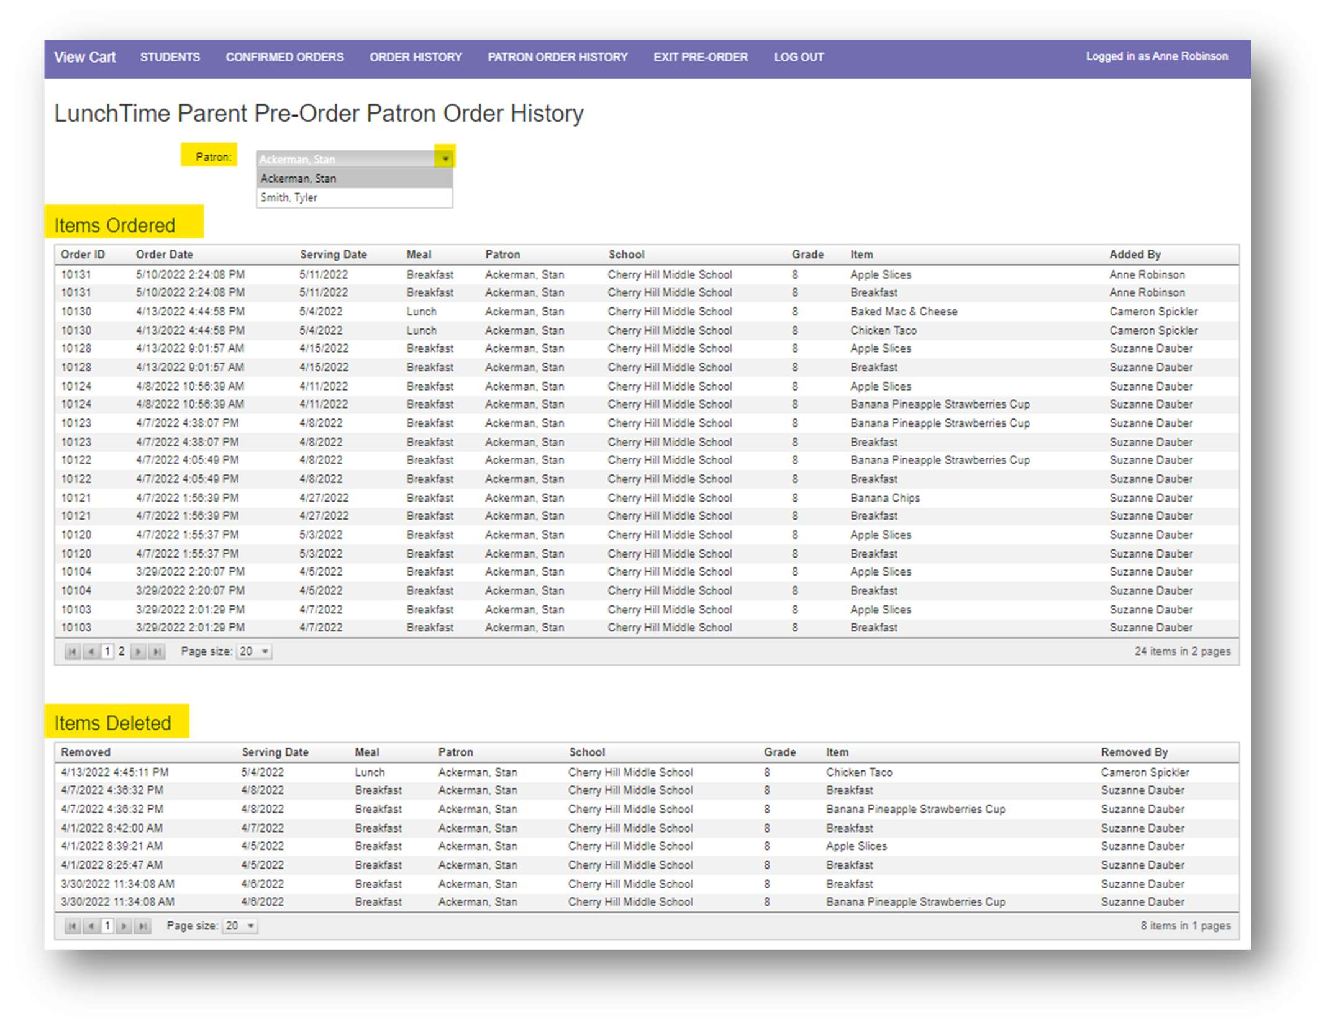

Exit Pre-Order
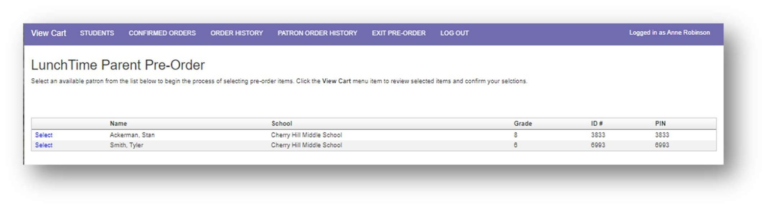
To exit out of the pre-order, click EXIT PRE-ORDER in the Menu Bar at the top of the screen.

You will be redirected back to the Student Access page.
Log Out
To Log Out of School Payment Portal, click LOG OUT in the Menu Bar at the top of the screen.
